SECOND TERM LESSON PLAN
CREATIVE ARTS AND DESIGN – B7 WEEK 1
Date: |  | Period: |  | Subject: Creative Arts & Design
Duration: |  |  |  | Strand: Design
Class: B7 |  | Class Size: |  | Sub Strand: Design in Nature and the  Manmade Environment
Content Standard: B7. 1.1.1. Demonstrate understanding of design as a concept in relation to the elements and principles of design and as a medium for creative expression of design in nature and the manmade environment. |  |  | Indicator: Indicator(s):  B7. 1.1.1.2  Research to identify and record what constitutes the ‘elements of design’ in nature and as building blocks for composition and creative expression of ideas. |  |  | Lesson:
Performance Indicator: Learners can identify and  record what constitutes the ‘elements of design’ in nature and as building blocks |  |  |  | Core Competencies:  CC7.5: CP5.1: CI6.2: DL5.6:
Reference: Creative arts and design curriculum Pg 3
Keywords: Dot, line, shape, texture, colour, value, form, space, and perspective.
Phase/Duration | Learners Activities |  |  |  | Resources
PHASE 1: STARTER | Revise with learners to review their understanding in the  previous lesson  Share performance indicators with learners.
PHASE 2: NEW  LEARNING | Guide Learners describe the elements of design found in  the natural environment.  Element of design are the basic units of a visual image. Examples are dot, line, shape, texture, colour, value.  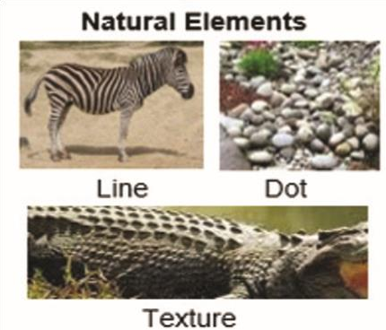  Brainstorm and experiment with tools and materials and watch video on natural environment. |  |  |  | Pictures, charts ,  Pencils, paper, charcoal, pencil, Pastel, crayon,  scissors, brushes

Discuss with the learners on how to apply the tools,
materials and equipment in making elements of design from nature.
Examples: Eye as Dot, Tail as line.
Assist learners to apply available tools and materials to create elements of design that reflect those found in nature and the manmade environment
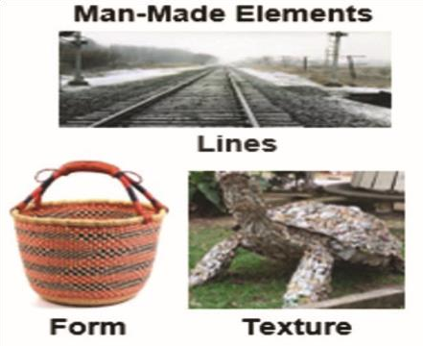

Learners talk about the steps involved in making elements of design from both natural and man-made environments
PHASE 3:  REFLECTION | Use peer discussion and effective questioning to find out  from learners what they have learnt during the lesson.  Take feedback from learners and summarize the lesson.

Date: |  | Period: |  | Subject: Creative Arts & Design
Duration: |  |  |  | Strand: Music
Class: B7 |  | Class Size: |  | Sub Strand: Media and techniques
Content Standard:  B7. 2.1.2.  Performing Arts - Music  Demonstrate understanding and apply scale, note durational values and simple time beat patterns in music. |  |  | Indicator:  B7 2.1.2.6  Identify durational symbols and move/perform their value in relation to the semibreve. |  |  | Lesson:
Performance Indicator:  Learners can identify durational symbols and move/perform their value in relation to the semibreve |  |  |  | Core Competencies:  CC7.2: CC9.6: CP 6.3: CI 5.5: CI 6.4: PL6.1:
Reference: Creative arts and design curriculum Pg 11
Keywords / vocabulary:
Rhythm, semibreve, minim, crotchet, quaver, semiquaver, rhythm, internalize, durational symbols, durational value, beat, pulse, rests
Phase/Duration | Learners Activities |  |  |  | Resources
PHASE 1: STARTER | Ask learners to play a stone passing game in small groups  around their tables.  Ask a learner to sing “Daa N’a se” and move to the song.
PHASE 2: NEW  LEARNING | Guide learners to explain the concept of rhythm.  Display the symbols for duration for learners to identify and learn their names. Describe the shapes of the musical notation and demonstrate how to write them. Ask learners to try and draw them on line and in space.  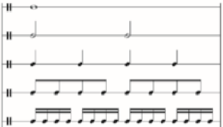  Ask learners to sing the first part of the ’Da N’a Se, Da N’a Ase’ song again now clapping every note in the song.  Ask them to figure out which symbols will represent the duration of the notes they clapped.  Discuss the numerical values of the symbols. |  |  |  | Image of durational symbols

Learners internalize the crotchet note as the beat (or
pulse). Take them through the clapping of the rhythmic patterns in their resource book
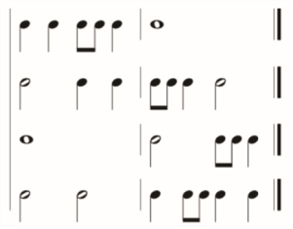

ASSESSMENT: Ask learners to write a one-bar rhythm for their peers to play on any available instruments
PHASE 3:  REFLECTION | Use peer discussion and effective questioning to find out  from learners what they have learnt during the lesson.  Take feedback from learners and summarize the lesson.

