Fayol Inc. 0547824419

SECOND TERM WEEKLY LESSON NOTES
CREATIVE ARTS AND DESIGN – B7 WEEK 5
Date: 10th JUNE, 2022 |  | DAY: |  | Subject: Creative Arts And Design
Duration: |  |  |  | Strand: Creative Arts
Class: B7 |  | Class Size: |  | Sub Strand: Media and Techniques
Content Standard:  B7. 2.1.1 Visual Arts:  Demonstrate understanding of relevant Visual Arts media and techniques and their application to still-life drawing, shading, pattern making and modelling |  |  | Indicator:  B7 2.1.1.3 Experiment by using the techniques to test and prepare clay, pulp paper (papier- mâché) for modelling |  |  | Lesson:
Performance Indicator:  Learners can demonstrate the techniques to test and prepare clay for modelling |  |  |  |  | Core Competencies:  CC9.4: CP5.2: CI5.1: DL5.3
Reference: Creative Arts And Design Curriculum P.g. 7
Phase/Duration | Learners Activities |  |  |  |  | Resources
PHASE 1:  STARTER | Show a video/ pictures on how to prepare and test clay and  pulp paper for modelling.  Learners answer questions to motivate them on how to prepare and test clay for modelling. For example. How do you prepare clay for modelling?
PHASE 2:  NEW LEARNING | Brainstorm learners and explain how to prepare and test clay  and pulp paper for modelling.  Guide learners to discuss the methods of preparing clay. Example: the wet and dry method  Preparing Pulp Paper  - Tear the newspaper, scrap paper into very small bits  - Beat the paper and water in the blender, or with egg beater, to make pulp.  - Pour the pulp into a flat pan.  - Slide the screen into the bottom of the pan and move it around until it is evenly covered with pulp, etc.  Let learners Identify and use hand building techniques for modelling in clay, play dough, plasticine, papier mâché (pulp paper). |  |  |  |  | pictures or  videos of hand building

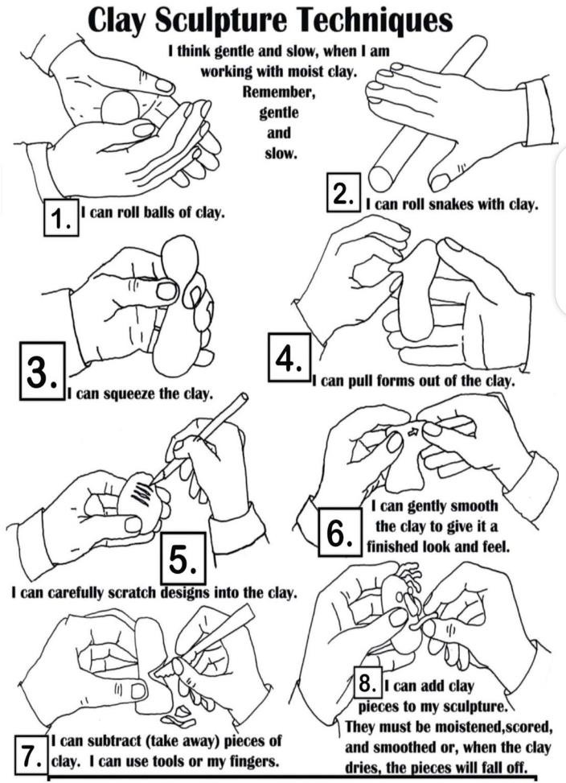

Let Learners practice the techniques in modelling in clay and play dough.
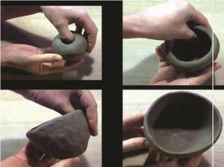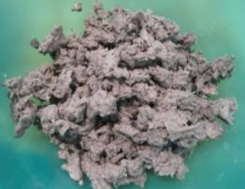

Assessment
- Briefly describe the methods of preparing clay for modelling.
- Identify any three items used for making pulp paper.
- State and explain any four techniques for modeling clay.
PHASE 3:  REFLECTION | Ask learners to tell what they have learnt.  Let learners display models for appreciation and reflection with

Date: 10th JUNE, 2022 |  | DAY: |  | Subject: Creative Arts And Design
Duration: |  |  |  | Strand: Creative Arts
Class: B7 |  | Class Size: |  | Sub Strand: Creative and  Aesthetic Expression
Content Standard:  B9. 2.2.2. Performing Arts - Music:  Exhibit competences in the application of the design process to produce and display own creative musical work that reflect a range of different times, cultures and topical issues |  |  | Indicator:  B9. 2.2.2.4  Design and produce own musical work that reflects a range of different times and cultures that promote and sensitize the public on emerging topical issues |  |  | Lesson:  1 of 1
Performance Indicator:  Learners can Design and produce own musical work. |  |  |  |  | Core Competencies:  CG5.3: CG6.1
Reference: Creative Arts And Design Curriculum P.g. 54
Phase/Duration | Learners Activities |  |  |  |  | Resources
PHASE 1:  STARTER | Let Learners sing “Da N’a Se, Da N’a Ase” song.  Draw learners attention to the new lesson’s content standard and indicator
PHASE 2: NEW  LEARNING | Have learners discuss the instruments used to accompany  marching into classes and also used during school worship. Ask learners to list as many as they have in the school.  Example: bass drum, snare, drum pati (Tom), conga.  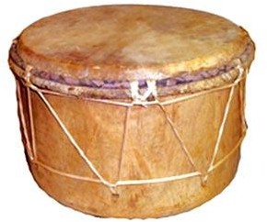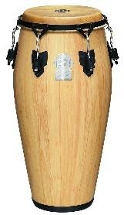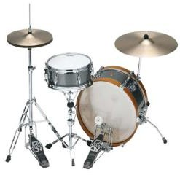  Pati drum(Tom) conga bass drum snare  Revise the previous lesson on rhythm (durational values). Ask learners to clap excerpts given for their homework last week.  Give out some of the percussive instruments and ask learners to play their rhythmic patterns on it.  Put learners into small groups to compose a short percussive music for any four percussive instruments by writing down the rhythmic patterns that should be played on each one. |  |  |  |  | Pictures\ video

Eg:
- Da N’a Se, Da N’a Ase
- Yâ Bô Tow Ebenezer
- Halleluyah! Soro Abôfo Tow Dwom
- Domfo Nyankopôn
Assessment:
  - Identify any four instruments used at school or church.
  - State the uses of the instruments identified above.
PHASE 3:  REFLECTION | Close the lesson by allowing learners to reflect, connect and  apply the knowledge acquired.  Ask learners to tell what they have learnt.

