Fayol Inc. 0547824419/0549566881
CREATIVE ARTS AND DESIGN – B7 WEEK 6
Date: 17th JUNE, 2022 |  | DAY: |  | Subject: Creative Arts and Design
Duration: |  |  |  | Strand: Design
Class: B7 |  | Class Size: |  | Sub Strand: Design in Nature and the  Manmade Environment.
Content Standard:  B7. 1.1.1. Demonstrate understanding of design as a concept in relation to the elements and principles of design and as a medium for creative expression of design in nature and the manmade environment. |  |  | Indicator:  B7. 1.1.1.2 Research to identify and record what constitutes the ‘elements of design’ in nature and as building blocks for composition and creative expression  of ideas. |  |  |  | Lesson:  1 OF 2
Performance Indicator:  Learners can identify and record what constitutes the elements of design’ in nature and as building blocks |  |  |  |  | Core Competencies:  CC7.5: CP5.1: CI6.2: DL5.6:
Reference: Creative Arts and Design Curriculum P.g. 3
Phase/Duration | Learners Activities |  |  |  |  | Resources
PHASE 1: STARTER | Revise with learners to review their understanding in the  previous lesson  Share performance indicators with learners.
PHASE 2: NEW  LEARNING | Guide Learners describe the elements of design found in the  natural environment.  Element of design are the basic units of a visual image. Examples are dot, line, shape, texture, colour, value.  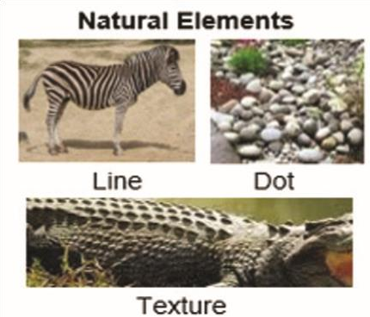  Brainstorm and experiment with tools and materials and watch video on natural environment.  Discuss with the learners on how to apply the tools, materials and equipment in making elements of design from nature.  Example: Eye as Dot, Tail as line.  Assist learners to apply available tools and materials to create elements of design that reflect those found in nature and the manmade environment. |  |  |  |  | Pictures, charts ,  Pencils, paper, charcoal, pencil,

PHASE 3:  REFLECTION | Learners talk about the steps involved in making elements of  design from both natural and man-made environments

Date: 17th JUNE, 2022 |  | DAY: |  | Subject: Creative Arts And Design
Duration: |  |  |  | Strand: Creative Arts
Class: B7 |  | Class Size: |  | Sub Strand: Media and Techniques
Content Standard:  B7. 2.1.1 Visual Arts:  Demonstrate understanding of relevant Visual Arts media and techniques and their application to still-life drawing, shading, pattern making and modelling |  |  | Indicator:  B7 2.1.1.3 Experiment by using the techniques to test and prepare clay,  pulp paper (papier-mâché) for modelling |  |  | Lesson:
Performance Indicator:  Learners can demonstrate the techniques to test and prepare clay for modelling |  |  |  |  | Core Competencies:  CC9.4: CP5.2: CI5.1: DL5.3
Reference: Creative Arts And Design Curriculum P.g. 7
Phase/Duration | Learners Activities |  |  |  |  | Resources
PHASE 1: STARTER | Show a video/ pictures on how to prepare and test clay and  pulp paper for modelling.  Learners answer questions to motivate them on how to prepare and test clay for modelling. For example. How do you prepare clay for modelling?
PHASE 2: NEW  LEARNING | Brainstorm learners and explain how to prepare and test clay  and pulp paper for modelling.  Guide learners to discuss the methods of preparing clay. Example: the wet and dry method  Preparing Pulp Paper  - Tear the newspaper, scrap paper into very small bits  - Beat the paper and water in the blender, or with egg beater, to make pulp.  - Pour the pulp into a flat pan.  - Slide the screen into the bottom of the pan and move it around until it is evenly covered with pulp, etc.  Let learners Identify and use hand building techniques for modelling in clay, play dough, plasticine, papier mâché (pulp paper). |  |  |  |  | pictures or  videos of hand building

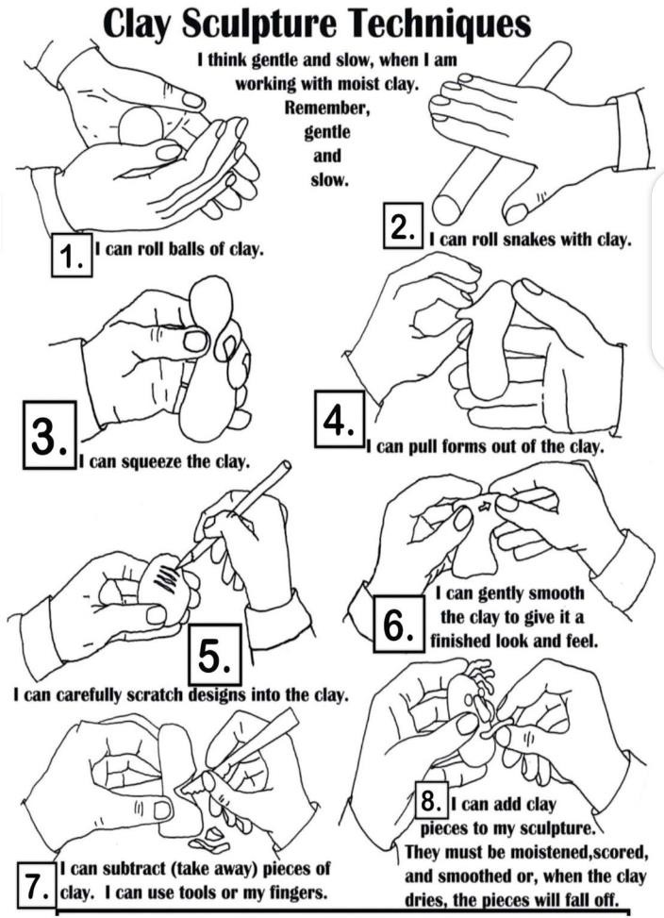

Let Learners practice the techniques in modelling in clay and play dough.
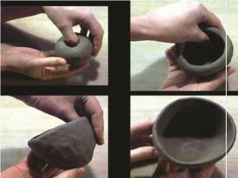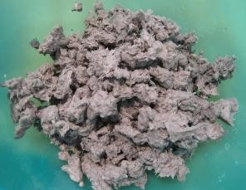

Assessment
- Briefly describe the methods of preparing clay for modelling.
- Identify any three items used for making pulp paper.
- State and explain any four techniques for modeling clay.
PHASE 3:  REFLECTION | Ask learners to tell what they have learnt.  Let learners display models for appreciation and reflection with

Date: 17th JUNE, 2022 |  | DAY: |  | Subject: Creative Arts And Design
Duration: |  |  |  | Strand: Creative Arts
Class: B7 |  | Class Size: |  | Sub Strand: Creative and Aesthetic  Expression
Content Standard:  B7. 2.2.3 Dance and Drama:  Demonstrate the ability to use concepts of design process (idea development) to produce and display own creative and expressive art-forms that reflect in the range of different times and cultures in dance and  drama. |  |  | Indicator:  B7.2.2.3.8 Plan a display of own and others’ artwork in dance and drama that reflect the history and culture of the community |  |  |  | Lesson:  1 of 1
Performance Indicator:  Learners can plan a display of own and others’ artwork in dance and drama |  |  |  |  | Core Competencies:  CG5.3: CG6.1
Reference: Creative Arts And Design Curriculum P.g. 17
Phase/Duration | Learners Activities |  |  |  |  | Resources
PHASE 1: STARTER | Review with learners what they learnt in the previous  lesson.  Draw learners attention to the new lesson’s content standard and performance indicators
PHASE 2: NEW  LEARNING | Guide learners to discuss how events (e.g. birthday  parties) are planned in the community.  Learners to plan a display of own music, dance and drama to educate and inform the public on the effects of topical issues experienced in the local community.  Discuss the need for performing collection of own or others music, dance and drama.  In groups, assist learners to discuss and come up with the following ideas:  - suitable venues,  - dates,  - time,  - chairs,  - canopies,  - public address system, etc.  Guide learners to select and agree on a theme for the performance.  Engage learners in the process of getting the audience by sending manual or electronic invitations (e.g. letters, postcards, WhatsApp). |  |  |  |  | Posters, notices,  letters, radio and TV sets, etc.

Let them select own or other people’s compositions for
the performance.

Guide learners to plan the sequence of events, stage plan identifying the positions of all facilities.
Engage learners in the Post-performance activities: cleaning, appreciation, appraisal, evaluation, reporting.
PHASE 3:  REFLECTION | Close the lesson by allowing learners to reflect, connect  and apply the knowledge acquired.  Ask learners to tell what they have learnt.

