Fayol Inc. 0547824419/0549566881
CREATIVE ARTS AND DESIGN – B7 WEEK 9
Date: 8th JULY, 2022 |  | DAY: |  | Subject: Creative Arts and Design
Duration: |  |  |  | Strand: Design
Class: B7 |  | Class Size: |  | Sub Strand: Design in Nature and the  Manmade Environment.
Content Standard:  B7. 1.1.1. Demonstrate understanding of design as a concept in relation to the elements and principles of design and as a medium for creative expression of design in nature and the manmade environment. |  |  | Indicator:  B7. 1.1.1.2 Research to identify and  record what constitutes the ‘elements of design’ in nature and as building blocks for composition and creative expression of ideas. |  |  |  | Lesson:  1 OF 2
Performance Indicator:  Learners can identify and record what constitutes the elements of design’ in nature and as building blocks |  |  |  |  | Core Competencies:  CC7.5: CP5.1: CI6.2: DL5.6:
Reference: Creative Arts and Design Curriculum P.g. 4
Phase/Duration | Learners Activities |  |  |  |  | Resources
PHASE 1: STARTER | Show video/ pictures on techniques in making elements of  design.  Let learners answer questions to motivate them on techniques in making elements of design
PHASE 2: NEW  LEARNING | Learners brainstorm and reflect on techniques in  creating elements of design.  Elements of design are found in natural and manmade objects. Examples: form, texture, shape, line, perspective, dot.  Guide learners identify the skills in creating elements of design and techniques by shading.  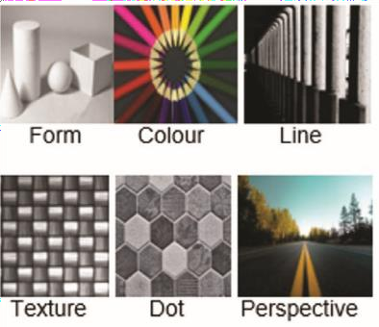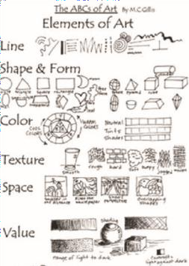  Drawing of elements  Assist learners practice the techniques in drawing and creating elements of design based on nature and the manmade environment |  |  |  |  | Pictures, charts ,  Pencils, paper, charcoal, pencil,

ASSESSMENT
- Draw three elements of design using different drawing, shading and coloring techniques.
- Using the techniques identified, create other elements of design by drawing, shading and coloring using different media.
PHASE 3:  REFLECTION | Learners talk about the steps involved in making elements of  design from both natural and man-made environments

Date: 8th JULY, 2022 |  | DAY: |  | Subject: Creative Arts And Design
Duration: |  |  |  | Strand: Creative Arts
Class: B7 |  | Class Size: |  | Sub Strand: Creative and Aesthetic  Expression
Content Standard:  Visual Arts: Demonstrate the ability to use concepts of design process (idea development) to produce and display own creative and expressive art-forms that reflect in the range of different times and cultures in  dance and drama. |  |  | Indicator:  Plan a display of own and others’ artworks that reflect the history and culture of the people in the community |  |  |  | Lesson:  1 of 1
Performance Indicator:  Learners can plan a display of own and others’ artwork in dance and drama |  |  |  |  | Core Competencies:  PL5.2: PL6.1: CG5.4: PL6.2
Reference: Creative Arts And Design Curriculum P.g. 14
Phase/Duration | Learners Activities |  |  |  |  | Resources
PHASE 1: STARTER | Ask learners to assemble at the performance ground for  the lesson.  Let learners composed for four percussive instruments a fortnight ago. Asked them to extend their compositions; had a rehearsal plan and appointed event planning committees.
PHASE 2: NEW  LEARNING | Assist learners gather and record relevant information  to demonstrate understanding and skill in keeping portfolio of artworks.  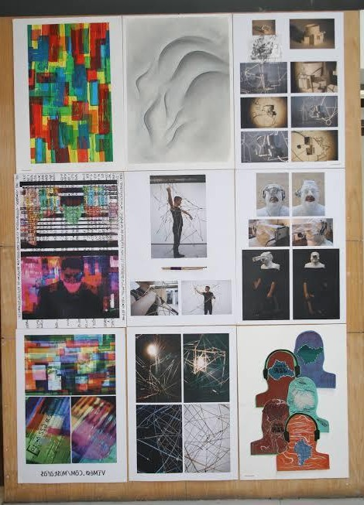 |  |  |  |  | Posters, notices,  letters, radio and TV sets, etc.

Learners apply understanding and skills in planning,
artworks in class, school and the community.
Guide learners apply understanding and skills in exhibiting artworks in class, school and the community.
Reflect and use comments to refine own and others’ artworks and the exhibition.
PHASE 3:  REFLECTION | Close the lesson by allowing learners to reflect, connect  and apply the knowledge acquired.  Ask learners to tell what they have learnt.

Date: 8th JULY, 2022 |  | DAY: |  | Subject: Creative Arts And Design
Duration: |  |  |  | Strand: Creative Arts
Class: B7 |  | Class Size: |  | Sub Strand: Creative and Aesthetic  Expression
Content Standard:  B7. 2.2.3 Dance and Drama:  Demonstrate the ability to use concepts of design process (idea development) to produce and display own creative and expressive art-forms that reflect in the range of different times and cultures in dance and drama. |  |  | Indicator:  Appreciate and appraise an indigenous and a non-traditional group within the community based on their style, instruments, song themes, dance movements, etc. |  |  |  | Lesson:  1 of 1
Performance Indicator:  Learners can demonstrate the ability to correlate and generate ideas from indigenous creative musical forms and art |  |  |  |  | Core Competencies:  PL5.2: PL6.1: CG5.4: PL6.2
Reference: Creative Arts And Design Curriculum P.g. 20
Phase/Duration | Learners Activities |  |  |  |  | Resources
PHASE 1: STARTER | Ask learners to assemble at the performance ground for  the lesson.  Let learners composed for four percussive instruments a fortnight ago. Asked them to extend their compositions; had a rehearsal plan and appointed event planning committees.
PHASE 2: NEW  LEARNING | Play the following video clips of indigenous musical forms  briefly and discuss the genres involved with the class, namely:  - Recitative song forms (nnwomkrɔ, ebibindwom, etc.),  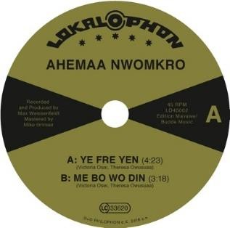  - Dance genre song forms (atsiagbekɔ, adowa, kete, baamaaya, etc.), vocal effects (yodelling, ululation, holler, nasalisation). |  |  |  |  | Posters, notices,  letters, radio and TV sets, etc.

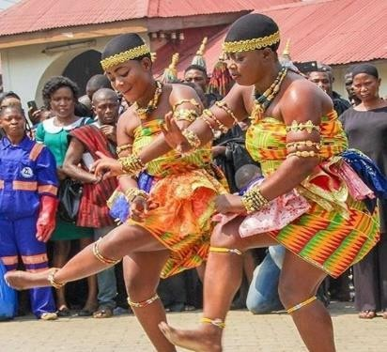

Explain briefly the four (4) basic aesthetic viewpoints in evaluating a musical art work, namely:
- Formalism
- Referentialism
- Absolutism
- Expressionism
Discuss with learners the basic elements of an indigenous and a neo-traditional group
Eg: origin, ethnic group, gender, age, instruments, song themes, dance movements, stylised dances, singing, drumming, costume, venue.

Put learners into small groups to research, select and document an indigenous and a neo-traditional group within the community on some of the elements discussed.

Ask groups to present the data collected on the indigenous and a neo-traditional group within the community to the class.
Ask other groups to comment on the data presented. Sum up the lesson, and ask groups to go and do more extensive research on the indigenous and a neo- traditional group within the community for presentation at the next lesson.
PHASE 3:  REFLECTION | Close the lesson by allowing learners to reflect, connect  and apply the knowledge acquired.  Ask learners to tell what they have learnt.

