SECOND TERM LESSON NOTES
WEEK 7
FAYOL INC. 0547824419

Date: 24th JUNE, 2022. |  | Period: |  | Subject: Career Technology
Duration: |  |  |  | Strand: Tools, Equipment & Processes
Class: B7 |  | Class Size: |  | Sub Strand: Joining And Assembling
Content Standard:  B7.3.3.1 Demonstrate understanding of joining and assembling materials, tools and equipment used for production |  |  | Indicator:  B7.3.3.1.2: Use appropriate skills for joining and assembling artefacts using the materials, tools and equipment |  | Lesson:  2 of 3
Performance Indicator:  Learners can demonstrate the appropriate techniques in  using joining and assembling materials and tools in Sewing and Food production. |  |  |  | Core Competencies:  CP6.5: Ability to select alternatives that adequately meet selected criteria
Reference: Career Technology Curriculum Pg. 21
Phase/Duration | Learners Activities |  |  |  |  | Resources
PHASE 1:  STARTER | Revise with learners to review their understanding in the  previous lesson.  Share performance indicators with learners.
PHASE 2: NEW  LEARNING | Demonstrate the appropriate techniques in using joining and  assembling materials and tools in Sewing and Food production:  Guide learners to discuss the types of stitches. Example: Temporary and Permanent.  Engage learners to demonstrate the types or classes of permanent stitches.  Example:  Joining Stitches – this includes running stitches, Back stitches, machine stitches and over sewing.  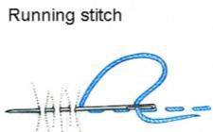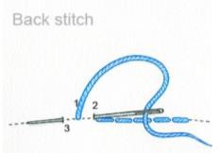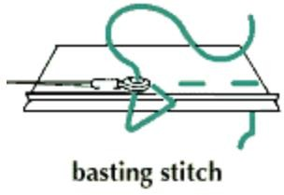  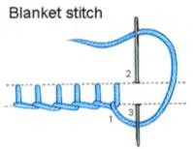  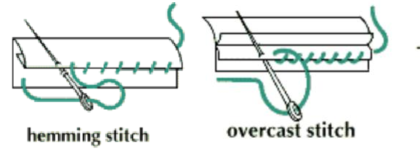  Neatening stitches – this includes loop stitches, hemming stitches and overcasting stitches. |  |  |  |  | Pictures and  Charts

Decorative stitches – this includes satin stitches, chain
stitches and laizy daizy stitches.
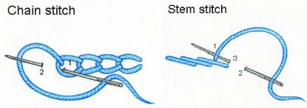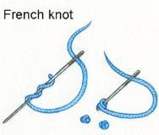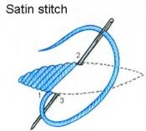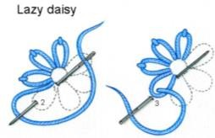
Guide learners to identify some methods of cooking food. Example: boiling and stewing
Brainstorm Learners for the meaning of boiling as a method of cooking food.
Boiling is a method of cooking food in enough boiling liquid at 100°C in a tightly covered saucepan.
Guide learners to discuss the types of boiling. Example:
- Boiling in which the stock is thrown away. E.g. boiled yam, boiled cassava, etc.
- Boiling in which food absorbs the liquid and increases in volume. For example, boiled rice, banku, etc.
- Boiling in which water forms part of food. For example, Porridge, rice porridge, oblayo, soup, etc.

Let learners describe how to boil a named food. Example: Method of boiling plantain.
- Wash, peel, cut and rewash plantain
- Place in a pan with water and add salt.
- Cover and boil until food is tender
- Strain off stock and serve hot with any stew.

Again, put learners in groups to describe steaming as a method of cooking food, the types of steaming and how to steam a named food
Call each group to present thier findings to the whole class.
PHASE 3:  REFLECTION | Use peer discussion and effective questioning to find out  from learners what they have learnt during the lesson.  Take feedback from learners and summarize the lesson.

Date: 24th JUNE, 2022. |  | Period: |  | Subject: Career Technology
Duration: |  |  |  | Strand: Tools, Equipment & Processes
Class: B7 |  | Class Size: |  | Sub Strand: Joining And Assembling
Content Standard:  B7.3.3.1 Demonstrate understanding of joining and assembling materials, tools and equipment used for production |  |  | Indicator:  B7.3.3.1.2: Use appropriate skills for joining and assembling artefacts using the materials, tools and equipment |  | Lesson:  2 of 2
Performance Indicator:  Learners can demonstrate the appropriate techniques in  using joining and assembling materials and tools in Metal and Block work. |  |  |  | Core Competencies:  CP6.5: Ability to select alternatives that adequately meet selected criteria
Reference: Career Technology Curriculum Pg. 21
Phase/Duration | Learners Activities |  |  |  |  | Resources
PHASE 1:  STARTER | Revise with learners to review their understanding in the  previous lesson.  Share performance indicators with learners.
PHASE 2: NEW  LEARNING | Demonstrate the appropriate techniques in using joining and  assembling materials and tools in Metal and Block work:  Engage learners and organize a trip to any Metal workshop in your community.  Have learners observe different types of nuts and bolts used for joining metal works.    Guide learners to identify the different types of adhesives used in metal works.  Metal adhesive is a natural or synthetic substance used to join or connect two or more metals surfaces together with a bond. |  |  |  |  | Pictures and  Charts

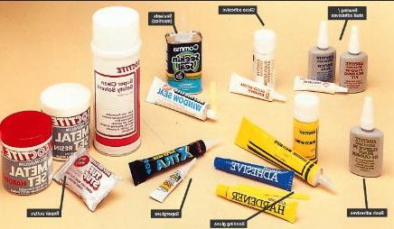
Brainstorm learners for the meaning of brick bonding.
Brick bonding is the arrangement of bricks in the mortar in a systematic manner in masonry construction.

Let learners explore the different types of brick bonding Example: stretcher bond, header bond, English bond, etc.

Using pictures, learners demonstrate how to construct some types of brick bonding.
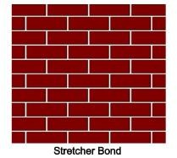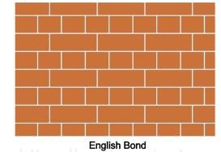

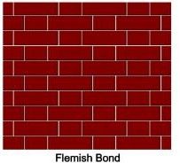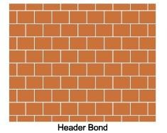
Guide learners to discuss the advantages and disadvantages of each of the type of bonding identified.
PHASE 3:  REFLECTION | Use peer discussion and effective questioning to find out  from learners what they have learnt during the lesson.  Take feedback from learners and summarize the lesson.

