SECOND TERM LESSON PLAN
CREATIVE ARTS AND DESIGN – B7
WEEK 8
Date: |  | Period: |  |  | Subject: Creative Arts And Design
Duration: |  |  |  |  | Strand: Design
Class: B7 |  |  | Class Size: |  | Sub Strand: : Design in Nature and the Manmade Environment
Content Standard: B7. 1.1.1.  Demonstrate understanding of design as a concept in relation to the elements and principles of design and as a medium for creative expression of design in nature and the manmade environment. |  |  |  | Indicator: B7 1.1.1.2  Research to identify and record what constitutes the ‘elements of design’ in nature and as building blocks for composition and creative expression of ideas. |  |  | Lesson:
Performance Indicator: Learners identify and record what constitutes the elements of design’ in nature |  |  |  |  |  | Core Competencies:  CC7.5: CP5.1: CI6.2: DL5.6:
Reference: Creative arts and design curriculum pg4
Keywords: Dot, line, shape, texture, colour, value, form, space, and perspective.
Phase/Duration | Learners Activities |  |  |  |  |  | Resources
PHASE 1: STARTER | Show video/ pictures on techniques in making elements of design.  Let learners answer questions to motivate them on techniques in making elements of design
PHASE 2: NEW  LEARNING | Learners brainstorm and reflect on techniques in creating elements of design.  Elements of design are found in natural and manmade objects.  Examples: form, texture, shape, line, perspective, dot.  Guide learners identify the skills in creating elements of design and techniques by shading.  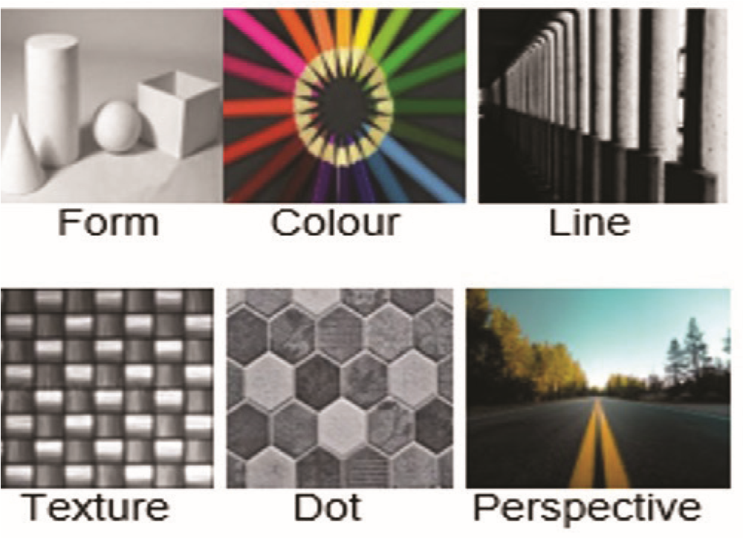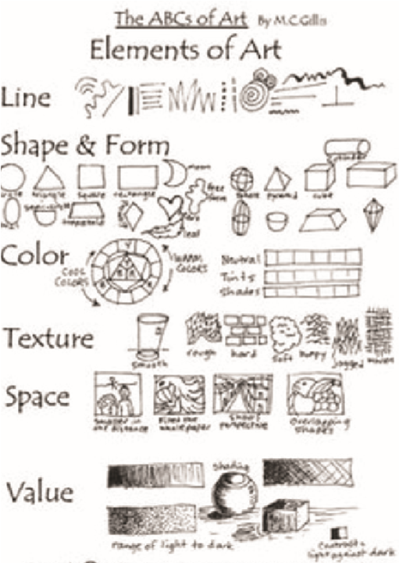  Drawing of elements  Assist learners Practise the techniques in drawing and creating elements of design based on nature and the manmade environment  ASSESSMENT  - Draw three elements of design using different drawing, shading and colouring techniques.  - Using the techniques identified, create other elements of design by drawing, shading and colouring using different media. |  |  |  |  |  | Picture/ video  Pencils, paper,  charcoal pencil pastel crayons scissors brushes
PHASE 3:  REFLECTION | Learners talk about the techniques used with their peers.

Date: |  | Period: |  |  | Subject: Creative arts and design
Duration: |  |  |  |  | Strand: Creative Arts
Class: B7 |  |  | Class Size: |  | Sub Strand: Media and Techniques
Content Standard: B7. 2.1.1 Visual Arts:  Demonstrate understanding of relevant Visual Arts media and techniques and their application to still-life drawing, shading, pattern making and modelling |  |  |  | Indicator: B7 2.1.1.3 Experiment by using the techniques to test and prepare clay, pulp paper (papier-mâché) for modelling |  |  | Lesson:
Performance Indicator: Learners can demonstrate the techniques to test and prepare clay for modelling |  |  |  |  |  | Core Competencies:  CC9.4: CP5.2: CI5.1: DL5.3
Reference: Creative arts and design curriculum pg 7
Keywords: Clay, play dough, plasticine, papier mâché (pulp paper), slab, pinch, coil, plasticity, kneading, wedging, spatulas
Phase/Duration | Learners Activities |  |  |  |  |  | Resources
PHASE 1: STARTER | Show a video/ pictures on how to prepare and test clay and pulp paper for modelling.  Learners answer questions to motivate them on how to prepare and test clay for modelling. For example. How do you prepare clay for modelling?
PHASE 2: NEW  LEARNING | Brainstorm learners and explain how to prepare and test clay and pulp paper for modelling.  Let learners Identify and use hand building techniques for modelling in clay, play dough, plasticine, papier mâché (pulp paper).  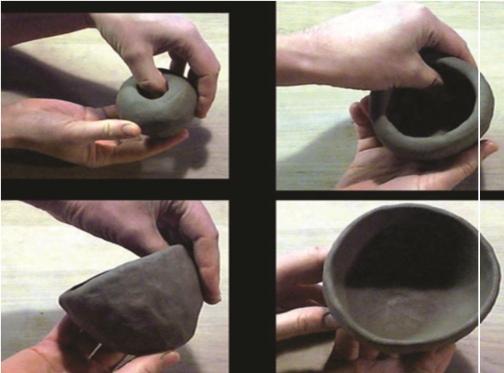  Let Learners practise the techniques in modelling in clay and play dough. |  |  |  |  |  | pictures or videos of hand building
PHASE 3:  REFLECTION | Ask learners to tell what they have learnt.  Let learners display models for appreciation and reflection with their peers.

Date: |  | Period: |  |  | Subject: Creative arts and design
Duration: |  |  |  |  | Strand: : Creative Arts
Class: B7 |  |  | Class Size: |  | Sub Strand: Creative And Aesthetic Expression
Content Standard: B7. 2.2.3  Dance and Drama  Demonstrate the ability to use concepts of design process (idea development) to produce and display own creative and expressive art-forms that reflect in the range of different times and cultures in dance and dram |  |  |  | Indicator: B7.2.2.3.9  Organise an appreciation and appraisal of own and others’ artworks in dance and drama that reflect the history and culture of the people of the community |  |  | Lesson:
Performance Indicator: Learners can demonstrate the ability to use concepts of design process to produce and display own creative |  |  |  |  |  | Core Competencies:  CP 6.7: CP 5.1:
Reference: Creative arts and design curriculum pg 17
Keywords: design, concept, artworks, aesthetic, organise history
Phase/Duration | Learners Activities |  |  |  |  |  | Resources
PHASE 1: STARTER | Engage learners to Perform some rhythmic and physical exercises.  Revise previous learning on planning a display of dance and drama performances.
PHASE 2: NEW  LEARNING | Guide learners to brainstorm on how to organise appreciation and appraisal events.    Guide learners to discuss why and how posters are made.  E.g: The uses or importance of posters, invitation letters, notices, etc      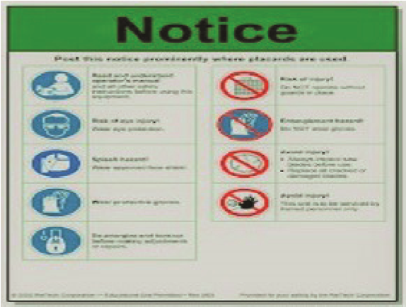  In groups, guide learners to design their own posters.  Post learners’ posters in the classroom and guide them to take a gallery-walk.  Guide learners to do a class discussion on the posters. |  |  |  |  |  | Picture/ video  Poster, letter and/or notices,
PHASE 3:  REFLECTION | Close the lesson by facilitating a discussion on posters designed by learners after the gallery-walk.  Summarise core-points for learners’ reflection

