Fayol Inc. 0547824419
WEEKLY LESSON NOTES – B7
WEEK 5

Strand : Productivity Software |  | Week Ending : 10TH JUNE, 2022
Sub Strand: Introduction to Electronic Spreadsheet |  | Duration :
Content Standard: B7.2.3.2. Demonstrate how to format a worksheet |  | Class : B7
Indicators: B7.2.3.2.1 Demonstrate how to adjust margins and set page  orientation |  | Day :
Core competences: DL5.1: Ability to ascertain when information is needed and be able to identify, locate, evaluate and effectively use it to
solve a problem.
Reference: Computing Curriculum P.g. 16
Activities For Learning & Assessment | Resources |  | Learners  Resource Page Ref. | Progression
Starter (5 mins)  Using questions and answers, revise the previous lesson with learners. Share performance indicators and introduce the lesson.  Main (35 mins)  Guide learners to demonstrate how to adjust margins and set page orientation for printing.  Adjusting Margins  - On the page layout tab, click margins, and then select custom margins.  - Use the arrows to increase or decrease the margin size in the appropriate box. When you are done, click Ok.  Page Setup | Computer with  Microsoft Excel, mouse or touchscreen input device, projector |  | Computing  Curriculum Pg. 9-10 | Learning how to  adjust margins and set page orientation for printing

- Press CTRL and then click each worksheet tab in the workbook that you want to affect
- On the file menu, click page setup. Click the dialog box launcher in the page setup group in the page layout tab.
- Make the changes that you want in the page setup dialog box, and then click Ok.

Demonstrate how to perform margin adjustment on different page sizes.
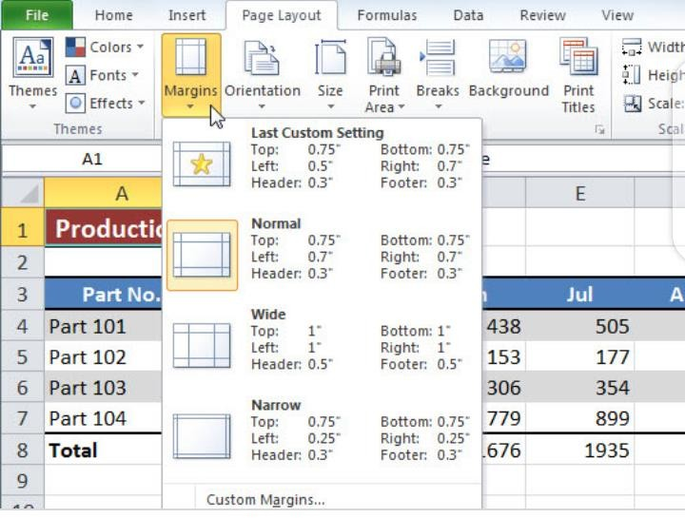

Guide learners to explore the display of worksheets in different views as listed on the View tab.

Reflection (10 mins)
We have learnt how to adjust margins and set page orientation for printing.

Engage learners in a think-pair-share activity on how to use other techniques for moving text.
Homework/Project Work/Community Engagement Suggestions
- Describe how to adjust margins for printing in Excel
- List four tools on the Page Layout tab and give one function of each.
Cross-Curriculum Links/Cross-Cutting Issues
None

The facilitator/teacher can arrange to use a nearby Senior High School (SHS) ICT laboratory
Potential Misconceptions/Student Learning Difficulties

Strand : Productivity Software |  | Week Ending: 10th JUNE, 2022
Sub Strand: Introduction to Electronic Spreadsheet |  | Duration :
Content Standard: B7.2.3.2. Demonstrate how to format a worksheet |  | Class : B7
Indicators: B7.2.3.2.2. Demonstrate how to set up a header and a footer. |  | Day :
Core competences: DL5.1: Ability to ascertain when information is needed and be able to identify, locate, evaluate and effectively use it to
solve a problem.
Reference: Computing Curriculum P.g. 16
Activities For Learning & Assessment | Resources |  | Learners  Resource Page Ref. | Progression
Starter (5 mins)  Using questions and answers, revise the previous lesson with learners. Share performance indicators and introduce the lesson. | Computer with  Microsoft Excel, mouse or touchscreen input device, projector |  | Computing  Curriculum Pg. 13-  14 | Learning how to set  up header and footer elements
Main (35 mins)
Guide learners to demonstrate to learners how to set up header and footer elements.
- On the inert tab, in the text group, click Header & Footer.
- To add or edit a header or footer text box at the top or the bottom of the worksheet page (under header, or above footer)
- Type the new header or footer text.
Engage learners to explore the use of page numbers, current date, time and file name in setting up headers and footers.

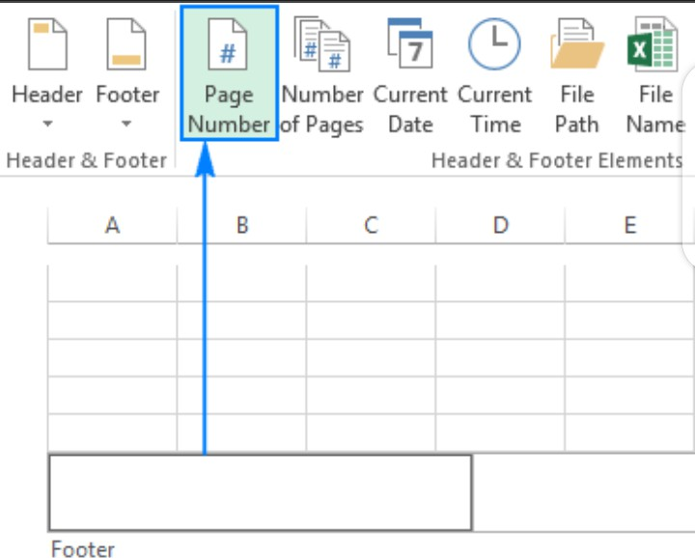

Reflection (10 mins)
We have learnt how to set up headers and footer elements.

Engage learners in a think-pair-share activity on how to use other techniques for moving text.
Homework/Project Work/Community Engagement Suggestions
Describe briefly how to set up header and footer elements in Excel.
Cross-Curriculum Links/Cross-Cutting Issues
None
Potential Misconceptions/Student Learning Difficulties
The facilitator/teacher can arrange to use a nearby Senior High School (SHS) ICT laboratory

