Fayol Inc. 0547824419
SECOND TERM WEEKLY LESSON NOTES WEEK 4
Date: 3RD JUNE, 2022 |  | DAY : |  | Subject: Mathematics
Duration: |  |  |  | Strand: Algebra
Class: B7 |  | Class Size: |  | Sub Strand: Patterns and Relations
Content Standard:  B7.2.1.1 Derive the rule for a set of points of a relation, draw a table of values to graph the relation in a number plane and make predictions about subsequent elements of the relation. |  |  | Indicator:  B7.2.1.1.2 Describe the rule for a given relation using mathematical language such as one more, one less, one more than twice, etc |  | Lesson:  2 of 3
Performance Indicator:  Learners can describe the rule for a given relation |  |  |  | Core Competencies:  Critical Thinking and Problem solving (CP)
References: Mathematics Curriculum Pg. 27-28
Phase/Duration | Learners Activities |  |  |  |  | Resources
PHASE 1: STARTER | Revise with learners on the previous lesson.  Call volunteer learners to the board to solve sample questions.  Introduce the lesson by sharing performance indicators.
PHASE 2: NEW  LEARNING | Guide learners to describe given relations.  To get the rule for a given relation, first identify how each pattern differs from the other.  For example, in the relation below, all the numbers in the domain are square root of the numbers in the co-domain. Or all the members in the co-domain are square of the numbers in the domain.  Therefore, we can describe the rule for this relation as “y = x²”.  Example:  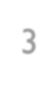  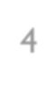    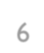  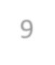  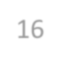  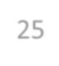    Domain Co-domain    2 4  3 9  4 16  5 25  6 36  To get the rule for a given relation, first identify how each pattern differs from the other. For example, in the relation below, all the |  |  |  |  | Abacus, Color  coded materials, place value chart, Number facts flash cards; Flashcards

numbers in the domain are half of the numbers in the co-domain. Or
all the members in the co-domain are doubles of the numbers in the domain.
Therefore, we can describe the rule for this relation as “x is half of y” or “y = 2x”.
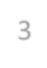
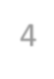
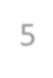
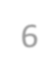
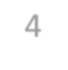
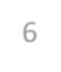
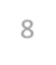
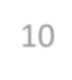
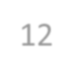

Domain Co-domain

2 4
3 6
4 8
5 10
6 12

The relation in the above is that the co-domain is a double of the domain.
Guide learners to describe the rule for a relation using mathematics language.

This table shows the pattern of cost of packed breakfast for workers on a field trip.

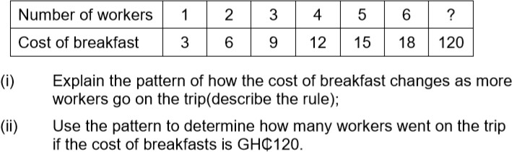

Engage learners to state the rules in words to represent a given relation.

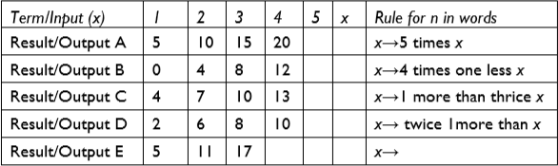

Have learners practice with more examples.
PHASE 3:  REFLECTION | Use peer discussion and effective questioning to find out  from learners what they have learnt during the lesson.  Take feedback from learners and summarize the lesson.

Shape number | 1 | 2 | 3 | 4 | 5 | 6 | 7 | 8 | 9
No. of  matchsticks | 3 | 5 | 7 | 9 | 11
Rule for the  pattern | Number of matchsticks = shape number x

Date: 3RD JUNE, 2022 |  | DAY : |  | Subject: Mathematics
Duration: |  |  |  | Strand: Algebra
Class: B7 |  | Class Size: |  | Sub Strand: Patterns and Relations
Content Standard:  B7.2.1.1 Derive the rule for a set of points of a relation, draw a table of values to graph the relation in a number plane and make predictions about subsequent elements of the relation. |  |  | Indicator:  B7.2.1.1.3 Identify the relation or rule in a pattern/mapping presented numerically or symbolically and predict subsequent elements |  | Lesson:  3 of 3
Performance Indicator:  Learners can identify the relation or rule in a pattern |  |  |  | Core Competencies:  Critical Thinking and Problem solving (CP)
References: Mathematics Curriculum Pg. 30-31
Phase/Duration | Learners Activities |  |  |  |  | Resources
PHASE 1: STARTER | Revise with learners on the previous lesson.  Call volunteer learners to the board to solve sample questions.  Introduce the lesson by sharing performance indicators.
PHASE 2: NEW  LEARNING | Guide learners to determine the rule for a given symbolic  pattern.  Guide learners to determine the rule for a given numerical pattern.  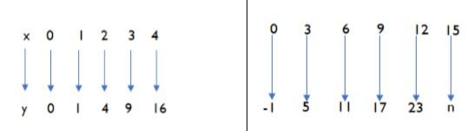  We can find the rule for the pattern by using either;  - The method of inspection.  Each number is mapped onto the sqaure of itself. Therefore if x stands for any element, then the rule for the pattern is y x2  - The method of difference  If it is obvious by inspection how to find the rule, the method of difference may be used. Find the difereence |  |  |  |  | Abacus, Color  coded materials, place value chart, Number facts flash cards; Flashcards

between elements in the co-domian and domain. If the 1st
difference are the same then we use the formula y= ax + b

a = 𝑐𝑜𝑛𝑠𝑡𝑎𝑛𝑡 𝑑𝑖𝑓𝑓𝑒𝑟𝑒𝑛𝑐𝑒 𝑜𝑓 𝑐𝑜−𝑑𝑜𝑚𝑎𝑖𝑛
𝑐𝑜𝑛𝑠𝑡𝑎𝑛𝑡 𝑑𝑖𝑓𝑓𝑒𝑟𝑒𝑛𝑐𝑒 𝑜𝑓 𝑑𝑜𝑚𝑎𝑖𝑛

domain = 0 3 6 9 12 co-domian = -1 5 11 17

3 3 3 3 6 6 6

therefore a = ⁶ = 2
3
Now we find b, which is a constant to be determined
using x = 3 and y = 5.
y= ax + b 5= 2(2) + b
b = 5-4
b = 1
therefore the rule is y= 2x + 1

Have learners practice with more examples in their workbooks.

Assessment
1. Find the rule for the following patterns
0 1 2 3 4 5

2 5 8 11 14 17

0 3 6 9 12

-1 5 11 17 23

0 1 2 3 4

2 4 6 8 10
PHASE 3:  REFLECTION | Use peer discussion and effective questioning to find out  from learners what they have learnt during the lesson.  Take feedback from learners and summarize the lesson.

