Fayol Inc. 0547824419

SECOND TERM WEEKLY LESSON NOTES WEEK 8
Date: 1st JULY, 2022 |  | DAY: |  | Subject: Mathematics
Duration: |  |  |  | Strand: Algebra
Class: B7 |  | Class Size: |  | Sub Strand: Variables and Equations
Content Standard:  B7.2.3.1 Demonstrate an understanding of linear equations of the form x + a = b (where a and b are integers) by modelling problems as a linear equation and solving the problems concretely, pictorially, and symbolically.. |  |  | Indicator:  B7.2.3.1.1 Translate word problems to linear equations in one variable and vice versa. |  | Lesson:  1 of 2
Performance Indicator:  Learners can translate word problems to linear equations in one variable and vice versa |  |  |  | Core Competencies:  Communication and Collaboration (CC) Critical Thinking and Problem solving (CP)
References: Mathematics Curriculum Pg. 40-42
Phase/Duration | Learners Activities |  |  |  |  | Resources
PHASE 1: STARTER | Can you work out what number will be at the top of the  pyramid?  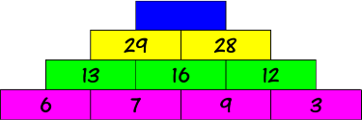  Write on the board: 𝑥 + 7 = 15 Ask learners;  - to identify the unknown variable. (Answer: 𝑥)  - What is the value of 𝑥?  Give some minutes to solve the problem and share their answers with the class.  Share learning indicators and introduce the lesson.
PHASE 2: NEW  LEARNING | Guide learners to use a flag diagram for equations and  their inverses to solve equations.  i. Think of a number, double it and subtract 7. The result is 41. What was the original number?  The flag diagram is:  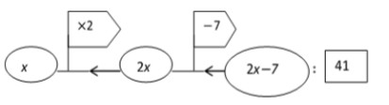  i.e. 2x− 7 = 41 |  |  |  |  | Counters, bundle  and loose straws base ten cut square, Bundle of sticks, rectangular cut out, bottle tops, algebra tiles

To solve the equation, move in the opposite direction
and do the inverse of the operations.

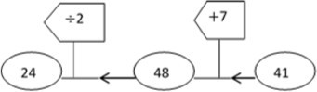

Guide learners to translate word problems to linear equations.
- The sum of the ages of two friends is 25, and the older one is 4 times that of the younger one. Write this as a mathematical sentence?
  - e. let the age of the younger one be x ∴the age of older one = 4x
4x + x = 25
  - Adaako and Afrakoma shared 40 oranges. Afrakoma had 6 more than Adaako. Write a mathematical sentence for this word problem.
i.e. let x represent Adaako’s share. ∴ Afrakoma’s share is
𝑥+6 and their share put together gives 40.
∴𝑥+(6+𝑥)=40
Have learners write word problems for given linear equations
- x + x = 15
  - e. the sum of two equal numbers is 15
  - 2𝑥 − 4 =12
i.e. when 4 is taken away from 2times a certain number,
the result is 12.

iii. ²𝑥 = 4
3
i .e. two-thirds of a certain number is 4.
Assessment
Ask students to describe two different stories that the equation 5 + k = 9 could represent.
First story: A book has 9 pages. Niko has 5 pages left to read. How many pages has he read?
Second story: The sum of a number k and 5 is equal to 9. What is the number?

Give learners more equations for them make up more stories from them
PHASE 3:  REFLECTION | Use peer discussion and effective questioning to find out  from learners what they have learnt during the lesson.  Take feedback from learners and summarize the lesson.

Date: 1st JULY, 2022 |  | DAY: |  | Subject: Mathematics
Duration: |  |  |  | Strand: Algebra
Class: B7 |  | Class Size: |  | Sub Strand: Variables and Equations
Content Standard:  B7.2.3.1 Demonstrate an understanding of linear equations of the form x + a = b (where a and b are integers) by modelling problems as a linear equation and solving the problems concretely, pictorially, and symbolically.. |  |  | Indicator:  B7.2.3.1.2 Model and solve linear equations using concrete materials |  |  | Lesson:  2 of 2
Performance Indicator:  Learners can model and solve linear equations using concrete materials |  |  |  | Core Competencies:  Communication and Collaboration (CC) Critical Thinking and Problem solving (CP)
References: Mathematics Curriculum Pg. 40-42
Phase/Duration | Learners Activities |  |  |  | Resources
PHASE 1:  STARTER | Using questions and answers, review to find out what learners  already know about Algebraic Expressions.  Share learning indicators and introduce the lesson.
PHASE 2: NEW  LEARNING | Guide learners use concrete materials, such as blocks or  counters and the balance scales, to find the value of variables in equations.  Let learners understand the rules involved in solving a linear equation by the balancing method.  - Add the same quantity to each side  - Subtract the same quantity from each side.  - Multiply each side by the same quantity  - Divide each side by the same quantity  For example: 3 + p =11      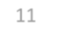  3 + p 11  With this example, we have to make both sides of the scale equal.  i.e. p + 3 - 3 = 11 – 3  p = 8 |  |  |  | Counters, bundle  and loose straws base ten cut square, Bundle of sticks, rectangular cut out, bottle tops, algebra tiles



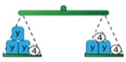
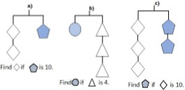
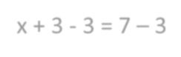
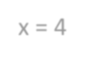
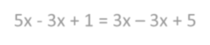
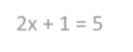
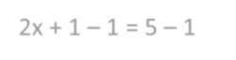

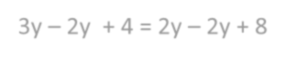
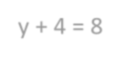
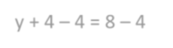
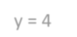
Guide learners to model and solve linear equations set with objects on a balance.

x + 3 = 7
x + 3 - 3 = 7 – 3
x = 4

5x + 1 = 3x + 5
5x - 3x + 1 = 3x – 3x + 5
2x + 1 = 5
2x + 1 – 1 = 5 – 1
2x = 4

3y + 4 = 2y + 8
3y – 2y + 4 = 2y – 2y + 8 y + 4 = 8
y + 4 – 4 = 8 – 4
y = 4

Model and guide learners to solve linear equations set with shapes on a balance
- In each balance the mass of one shape is given in grams. Find the mass of the other shape.

- In each balance the mass of one rhombus is 12 grams. Find the mass of the pentagon.

Assessment
Have learners to solve puzzle in the figure, by solving the equations in each line.

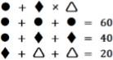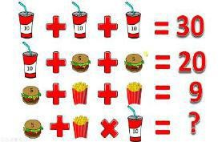

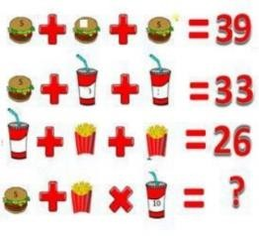
PHASE 3:  REFLECTION | Use peer discussion and effective questioning to find out from  learners what they have learnt during the lesson.  Take feedback from learners and summarize the lesson.

