Fayol Inc. 0547824419
SECOND TERM LESSON PLAN SOCIAL STUDIES – B7
WEEK 3

Date: 27th MAY, 2022 |  | DAY: |  | Subject: Social Studies
Duration: |  |  |  | Strand: Environment
Class: B7 |  | Class Size: |  | Sub Strand: Understanding Our Natural  World
Content Standard:  B7.1.3.1. Show understanding of the world around us |  |  | Indicator:  B7.1.3.1.1. Examine major physical features of the earth. |  | Lesson:  2 OF 3
Performance Indicator:  Learners can explore the major physical features of the earth. |  |  |  | Core Competencies:  CP 5.6: CI 5.4: CI 6.4: CP 5.1:
References: Social Studies Curriculum Pg. 9 -10
Phase/Duration | Learners Activities |  |  |  |  | Resources
PHASE 1: STARTER | Revise with learners to review their understanding in the  previous lesson.  Share performance indicators with learners.
PHASE 2: NEW  LEARNING | Revise with learners to mention some of the mountain  ranges in Ghana. Example:  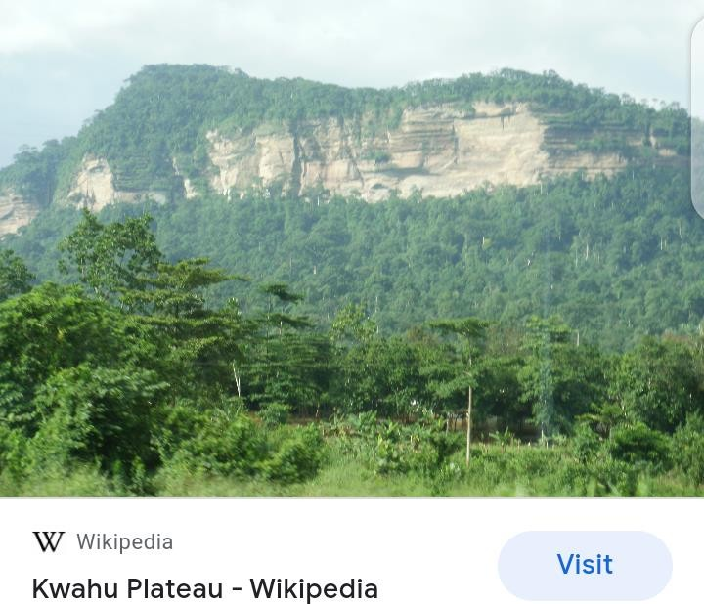 |  |  |  |  | Pictures and Charts

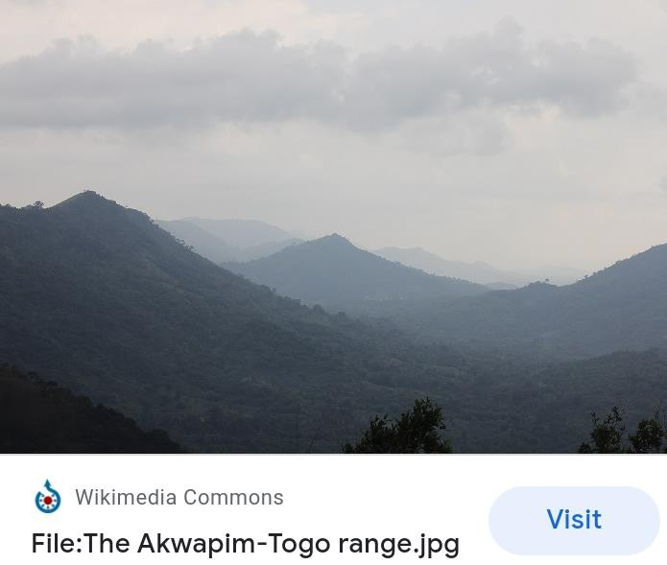

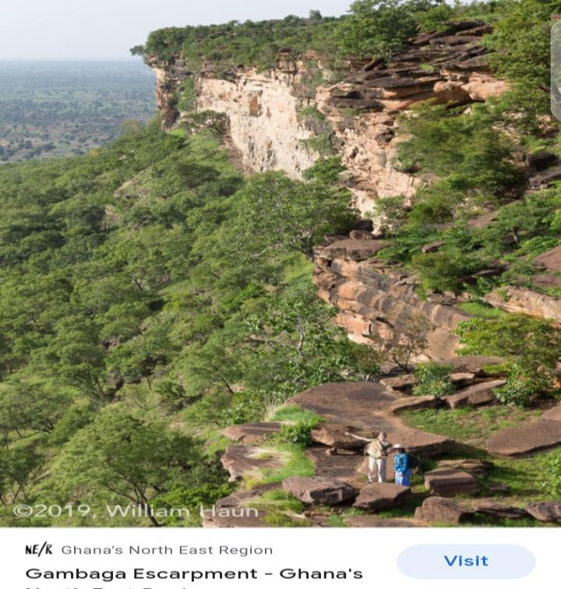

Engage learners to discuss human activities that affect the Major mountain ranges.
Example: mining, grazing by livestock, tourism, energy production, etc.

Learners discuss ways of maintaining the beauty of the mountain ranges.

Use pictures / photographs to assist pupils Identify some
major rivers in Ghana. Example:
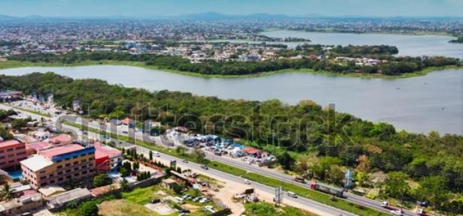

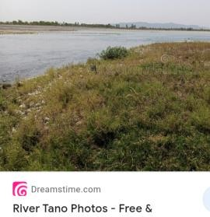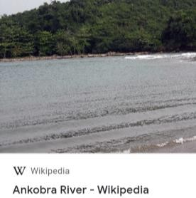
Engage learners to discuss human activities that affect the Rivers.
Example:
- The discharge of industrial chemicals
- Poor fishing methods such as the use of dangerous chemicals like DDT.
- Dumping of solid and liquid waste, etc.

Discuss the effects of plastic pollution on water bodies including streams, ponds, rivers, dams and lakes.
PHASE 3:  REFLECTION | Use peer discussion and effective questioning to find out  from learners what they have learnt during the lesson.  Take feedback from learners and summarize the lesson.

Date: 27th MAY, 2022 |  | Period: |  | Subject: Social Studies
Duration: |  |  |  | Strand: Environment
Class: B7 |  | Class Size: |  | Sub Strand: Understanding Our Natural  World
Content Standard:  B7.1.3.1. Show understanding of the world around us |  |  | Indicator:  B7.1.3.1.1. Examine major physical features of the earth. |  | Lesson:  3 OF 3
Performance Indicator:  Learners can explore the major physical features of the earth. |  |  |  | Core Competencies:  CP 5.6: CI 5.4: CI 6.4: CP 5.1:
References: Social Studies Curriculum Pg. 9 -10
Phase/Duration | Learners Activities |  |  |  |  | Resources
PHASE 1: STARTER | Revise with learners to review their understanding in the  previous lesson.  Share performance indicators with learners.
PHASE 2: NEW  LEARNING | Using pictures / photographs, assist learners to explore  the major oceans as a feature of the earth. Example:  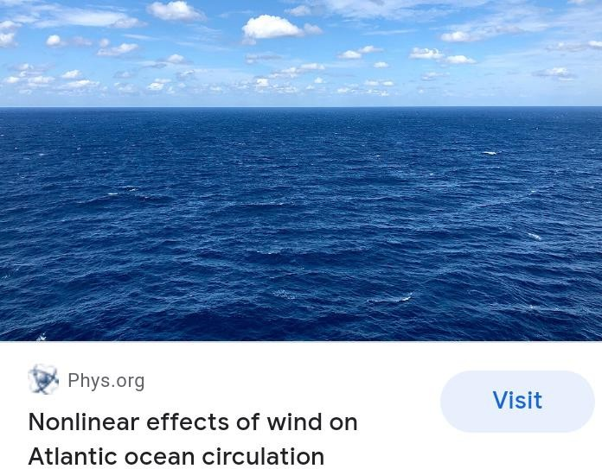  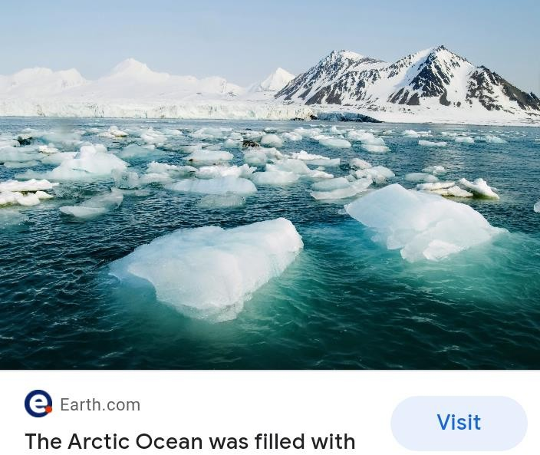 |  |  |  |  | Pictures and Charts

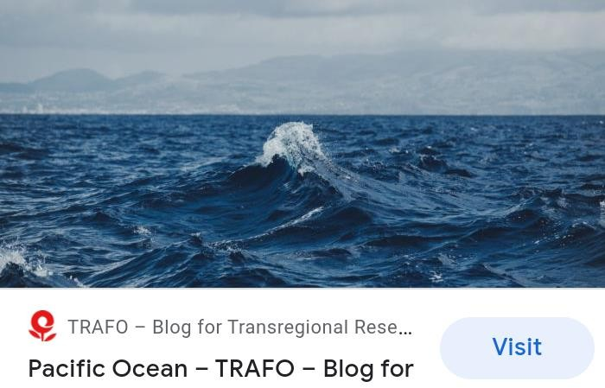

Let learners talk about some importance of the ocean to the humankind.
Example:
- The ocean produces over half of the world’s oxygen and absorbs 50 times more carbon dioxide than the atmosphere.
- The oceans regulate our climate and weather patterns.
- It serves as a means of transport.
- We also get food (fish) from it

Engage learners to discuss human activities that affect the ocean.
Example: sewage, toxic chemicals from industries, land runoff, large scale oil spills, ocean mining, littering, etc.

Discuss the effects of plastic pollution on water bodies including oceans.
PHASE 3:  REFLECTION | Use peer discussion and effective questioning to find out  from learners what they have learnt during the lesson.  Take feedback from learners and summarize the lesson.

