Fayol Inc. 0547824419
SECOND TERM WEEKLY LESSON NOTES
WEEK 4

Date: 3rd JUNE, 2022 |  | DAY: |  | Subject: Social Studies
Duration: |  |  |  | Strand: Environment
Class: B7 |  | Class Size: |  | Sub Strand: Understanding Our Natural World
Content Standard:  B7.1.3.2 Assess the issue of natural disasters and their management |  |  | Indicator:  B7.1.3.2.1. Examine natural disasters in the environment. |  | Lesson:  1 OF 3
Performance Indicator:  Learners can examine natural disasters in the environment. |  |  |  | Core Competencies:  CP 5.6: CI 5.4: CI 6.4: CP 5.1:
References: Social Studies Curriculum Pg. 9 -10
Phase/Duration | Learners Activities |  |  |  |  | Resources
PHASE 1: STARTER | Revise with learners to review their understanding in the  previous lesson.  Share performance indicators with learners.
PHASE 2: NEW  LEARNING | Brainstorm learners to explain natural disasters.  Natural disaster can be described as any misfortune that occurs from natural phenomena.  Learners share experience from the recent flooding caused by the rains in parts of Accra.  Show pictures or have learners to watch documentaries on some natural disasters.  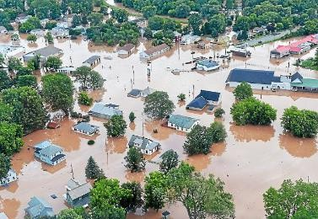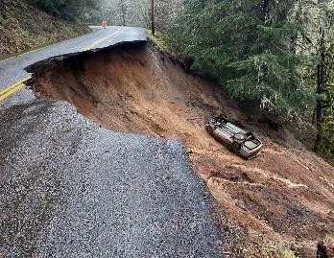    flooding landslide  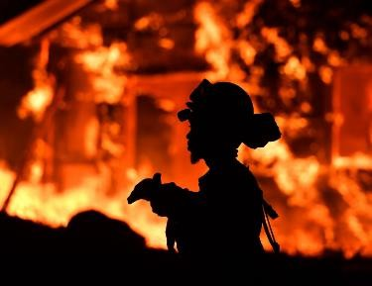  landslide |  |  |  |  | Pictures and Charts

Let learners mention examples of natural disasters,
including flood, drought, landslide, wildfire, earthquake and sea erosion.
PHASE 3:  REFLECTION | Use peer discussion and effective questioning to find out  from learners what they have learnt during the lesson.  Take feedback from learners and summarize the lesson.

Date: 3rd JUNE, 2022 |  | DAY: |  | Subject: Social Studies
Duration: |  |  |  | Strand: Environment
Class: B7 |  | Class Size: |  | Sub Strand: Understanding Our Natural  World
Content Standard:  B7.1.3.2 Assess the issue of natural disasters and their management |  |  | Indicator:  B7.1.3.2.1. Examine natural disasters in the environment. |  | Lesson:  1 OF 3
Performance Indicator:  Learners can examine natural disasters in the environment. |  |  |  | Core Competencies:  CP 5.6: CI 5.4: CI 6.4: CP 5.1:
References: Social Studies Curriculum Pg. 9 -10
Phase/Duration | Learners Activities |  |  |  |  | Resources
PHASE 1: STARTER | Revise with learners to review their understanding in the  previous lesson.  Share performance indicators with learners.
PHASE 2: NEW  LEARNING | Revise with learners some examples of natural disasters.  Example: flooding, earthquake, etc.  Brainstorm learners for the meaning of flooding.  Flooding is the over flowing of water onto land that is normally dry.  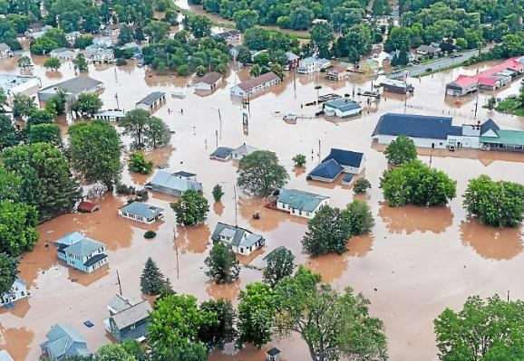  Guide learners to discuss the causes of flooding.  - Heavy rains  - Overflowing rivers  - Collapsed dams  - Snowmelt  - Climate change  In groups, let learners discuss the effects of flooding. Example:  - Loss of human life  - Damage of property  - Destruction of crops  - Loss of livestock  - Deterioration of health conditions owing to waterborne disease |  |  |  |  | Pictures and Charts

Again, engage learners to discuss the causes and effect of
earthquake.
Earthquake, also known as tremor or temblor, is the shaking of the surface of the earth resulting from a sudden release of energy in the earth’s lithosphere that creates seismic waves.
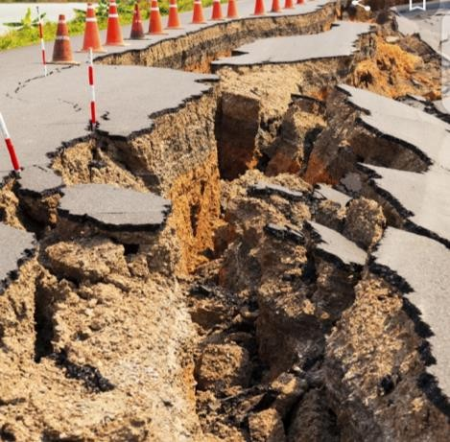
When the stress on the edge overcomes the friction, there is an earthquake that releases energy in waves that travel through the earth’s crust and causes the shaking that we feel.

Assessment
- Identify and explain three causes of flooding.
- Explain three effects of Earthquake.
PHASE 3:  REFLECTION | Use peer discussion and effective questioning to find out  from learners what they have learnt during the lesson.  Take feedback from learners and summarize the lesson.

