Fayol Inc. 0547824419
SECOND TERM WEEKLY LESSON NOTES
WEEK 5

Date: 10th JUNE, 2022 |  | DAY: |  | Subject: Social Studies
Duration: |  |  |  | Strand: Environment
Class: B7 |  | Class Size: |  | Sub Strand: Understanding Our Natural World
Content Standard:  B7.1.3.2 Assess the issue of natural disasters and their management |  |  | Indicator:  B7.1.3.2.1. Examine natural disasters in the environment. |  | Lesson:  1 OF 2
Performance Indicator:  Learners can examine natural disasters in the environment. |  |  |  | Core Competencies:  CP 5.6: CI 5.4: CI 6.4: CP 5.1:
References: Social Studies Curriculum Pg. 9 -10
Phase/Duration | Learners Activities |  |  |  |  | Resources
PHASE 1:  STARTER | Revise with learners to review their understanding in the previous  lesson.  Share performance indicators with learners.
PHASE 2: NEW  LEARNING | Revise with learners some examples of natural disasters.  Example: wildfire, earthquake, landslide, etc.  Brainstorm learners for the meaning of Wildfire.  Wildfire is an unplanned, uncontrolled and unpredictable fire in an area of combustible vegetarian starting in rural and urban areas..  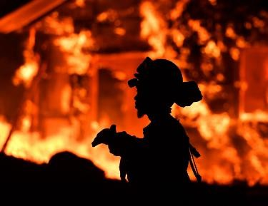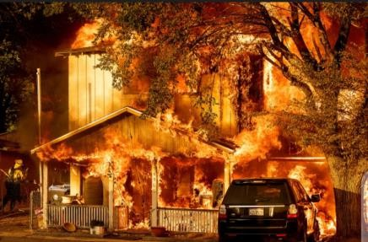  wildfire  Guide learners to discuss the causes of flooding.  - Burning debris  - cigarette  - Lighting  - Fireworks  - Volcanic eruption  In groups, let learners discuss the effects of flooding. Example:  - Loss of human life  - Damage of property |  |  |  |  | Pictures and  Charts

- Destruction of crops
- Loss of livestock

Again, engage learners to discuss the causes and effect of landslide.
Landslide is the movement of a mass of rock, debris, or earth down a slope.
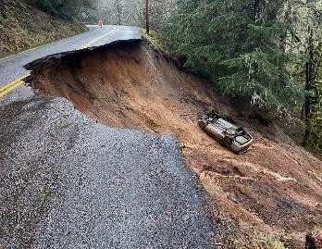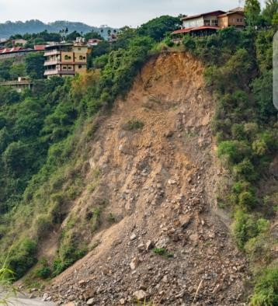
Landslide

Causes of landslides
- Deforestation
- Shifting cultivation
- Heavy rainfall and earthquakes
- Mining
- Urbanization.

In groups, learners discuss the effects of landslide on humans and properties.
Loss of life
Destruction of infrastructure Damage to land, etc.

Leaders of each group presents their findings to the whole class. Encourage learners to ask questions after each presentation.
Assessment
- State and explain any three causes and effects of landslide
- State and explain any three causes and effects of wildfire
PHASE 3:  REFLECTION | Use peer discussion and effective questioning to find out from  learners what they have learnt during the lesson.  Take feedback from learners and summarize the lesson.

Date: 10th JUNE, 2022 |  | DAY: |  | Subject: Social Studies
Duration: |  |  |  | Strand: Environment
Class: B7 |  | Class Size: |  | Sub Strand: Understanding Our Natural World
Content Standard:  B7.1.3.2 Assess the issue of natural disasters and their management |  |  | Indicator:  B7.1.3.2.1. Examine natural disasters in the environment. |  |  | Lesson:  2 OF 2
Performance Indicator:  Learners can describe how to manage natural disasters in the environment. |  |  |  |  | Core Competencies:  CP 5.6: CI 5.4: CI 6.4: CP 5.1:
References: Social Studies Curriculum Pg. 9 -10
Phase/Duration | Learners Activities |  |  |  |  |  | Resources
PHASE 1: STARTER | Revise with learners to review their understanding in the  previous lesson.  Share performance indicators with learners.
PHASE 2: NEW  LEARNING | Engage learners to discuss ways to managing natural  disasters.  Example: How to reduce the risk of; Landslides  - Modifying slope geometry  - Using chemicals agents to reinforce slope material  - Installing structures such as piles and retaining walls  - Grouting rock joints and fissures  - Diverting debris pathways, etc.  Wildfire  Check weather and drought conditions  Build campfire in an open location and far from flammables Keep vehicles off dry grass  Regularly maintain your equipment and vehicles, etc.  Guide learners to discuss the role of institutions responsible for early detection and management of natural disasters in Ghana, including Ghana Meteorological Agency (GMA), National Disaster Management Organisation (NADMO).  Assessment  - State four functions of the Ghana Meteorological Agency (GMA)  - Briefly explain the role of the National Disaster Management Organisation (NADMO) |  |  |  |  |  | Pictures and Charts
PHASE 3:  REFLECTION | Use peer discussion and effective questioning to find out  from learners what they have learnt during the lesson.  Take feedback from learners and summarize the lesson.

