SECOND TERM
WEEKLY LESSON NOTES WEEK 1
FAYOL INC. 0547824419

Week Ending: 06-04-2023 |  | Day: |  | Subject: Career Technology
Duration: 60MINS |  |  |  | Strand: Tools, Equipment & Processes
Class: B8 |  | Class Size: |  | Sub Strand: Care for Measuring & Marking  Out Tools
Content Standard:  B8.3.1.1 Demonstrate understanding of measuring and marking out tools and equipment for production |  |  | Indicator:  B8.3.1.1.4: Demonstrate how to care for and maintain measuring and marking out tools used for production. |  |  |  | Lesson:  1 of 2
Performance Indicator:  Learners can identify tools and equipment for measuring and marking out |  |  |  |  | Core Competencies:  CP 6.5: CI 5.4: CI 5.2: CI 6.10:
Reference: Career Technology Curriculum Pg. 54
Phase/Duration | Learners Activities |  |  |  |  | Resources
PHASE 1:  STARTER | Revise with learners to review their understanding in the  previous lesson.  Share performance indicators with learners.
PHASE 2: NEW  LEARNING | Guide learners to identify from displayed realia or pictures,  tools and equipment used for measuring and marking out in the Food laboratory (kitchen for liquids/dry ingredients: weighing scale, measuring cups, spoons, calabash, olonka.  Guide learners to describe the procedure for measuring and marking out products in the Food laboratory (kitchen).  Measuring cups and spoons: These tools come in different sizes and are used to measure both liquid and dry ingredients. Measuring cups are typically used for larger quantities, while spoons are used for smaller amounts.  Kitchen scale: A kitchen scale is used to measure ingredients by weight, which is especially important for baking. It can also be used to measure portion sizes.  Ruler: A ruler is a simple tool used to measure the size of ingredients or to mark out the dimensions of a dish.  Tape measure: A tape measure is used to measure larger items, such as the size of a baking sheet or the diameter of a cake pan.  Marking knife: A marking knife is a small, sharp knife used to mark out the dimensions of a dish or to score the surface of bread dough.  Decorating stencils: These stencils are used to create precise designs on cakes and other baked goods.  Piping bags and tips: Piping bags and tips are used to create decorative designs on cakes and other desserts |  |  |  |  | Pictures and  charts of food

Sketch and label parts of some measuring and marking out
tools and equipment.
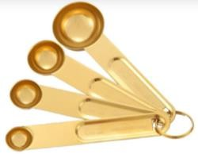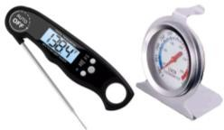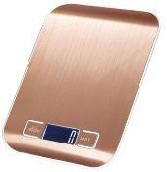
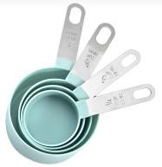

Measuring spoons Measuring spoons Digital weighing scale


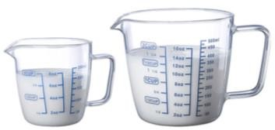
Measuring cups Measuring Jug
Engage learners to present the sketched tools and equipment for appraisal in class.
Share experiences from home on how to care for tools and equipment for production.
Identify cleaning agents/materials used to clean and maintain tools and equipment based on the respective material used in making the tool.
E.g., Silvo for cleaning silver, Brasso for cleaning brass, oil to avoid rust, cloth for cleaning and dusting.
Demonstrate how to clean measuring and marking out tools and equipment according to the materials used in making them.
Assessment
- What tool is used to measure both liquid and dry ingredients in the kitchen?
- Which tool is used to measure ingredients by weight?
- What is the purpose of a marking knife in the kitchen?
- Name a tool used to measure the size of a baking sheet or the diameter of a cake pan.
- What are piping bags and tips used for in the kitchen?
PHASE 3:  REFLECTION | Use peer discussion and effective questioning to find out  from learners what they have learnt during the lesson. Take feedback from learners and summarize the lesson.  Ask learners how the lesson will benefit them in their daily lives.  Homework  - What is the purpose of a ruler in the kitchen?  - Can decorating stencils be used to create designs on cakes and other baked goods? Yes/No

- Why is it important to be precise in your measurements and
markings when cooking and baking?
- Name one common measuring tool used for smaller amounts of ingredients.
- Which tool is used to create decorative designs on cakes and other desserts?

Week Ending: 06-04-2023 |  | Day: |  | Subject: Career Technology
Duration: 60MINS |  |  |  | Strand: Tools, Equipment & Processes
Class: B8 |  | Class Size: |  | Sub Strand: Care for Measuring & Marking  Out Tools
Content Standard:  B8.3.1.1 Demonstrate understanding of measuring and marking out tools and equipment for production |  |  | Indicator:  B8.3.1.1.4: Demonstrate how to care for and maintain measuring and marking out tools used for production |  |  |  | Lesson:  2 of 2
Performance Indicator:  Learners can identify tools and equipment for measuring and marking out |  |  |  |  | Core Competencies:  CP 6.5: CI 5.4: CI 5.2: CI 6.10:
Reference: Career Technology Curriculum Pg. 54
Phase/Duration | Learners Activities |  |  |  |  | Resources
PHASE 1:  STARTER | Revise with learners to review their understanding in the  previous lesson.  Share performance indicators with learners.
PHASE 2: NEW  LEARNING | Guide learners to identify from displayed realia or pictures,  tools and equipment used for measuring and marking out in the sewing laboratory.  Guide learners to describe the procedure for measuring and marking out products in the sewing workshop.  Measuring tape: This is a flexible tape used to measure fabric length, width, and circumference. It's commonly used for taking body measurements and for measuring fabric for clothing patterns.  Ruler: A ruler is a straightedge used for measuring and marking straight lines. It can be made of plastic or metal and comes in various lengths. It's ideal for measuring hems, seams, and other precise measurements.  French curve: This is a curved tool used for drawing and adjusting curves in patterns. It's great for creating smooth lines for armholes, necklines, and sleeve caps.  Tailor's chalk: This is a soft chalk used for marking fabric. It's easily visible and can be removed with a brush or damp cloth. It's ideal for marking hems, darts, and other sewing lines.  Tracing paper: This is a thin, semi-transparent paper used for transferring pattern markings onto fabric. It's often used for marking darts and pleats.  Seam gauge: This is a small ruler with a sliding marker used for measuring seam allowances and hems.  Pin cushion: This is a small cushion used for holding pins and needles. It's a handy tool to keep pins within easy reach while sewing. |  |  |  |  | Pictures and  charts of food

Sketch and label parts of some measuring and marking out
tools and equipment used in the sewing workshop.

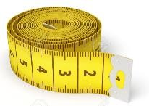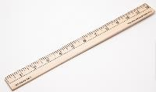

Tape measure Meter rule

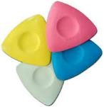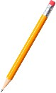
Tailors chalk Pencil

Engage learners to present the sketched tools and equipment for appraisal in class.
Demonstrate how to clean measuring and marking out tools and equipment according to the materials used in making them.
- Store the tools in a dry and clean place to prevent rust, moisture, or damage.
- After use, wipe the tools with a clean cloth to remove any dirt or debris.
- Keep the tools organized and in their designated places to prevent them from getting lost or damaged.
- Avoid dropping or banging the tools as they may become damaged or lose their accuracy.
- Sharpen and clean cutting tools such as scissors and rotary cutters regularly to maintain their sharpness and prevent snagging fabric.

Assessment
- What is a measuring tape used for in a sewing laboratory?
- What is the purpose of a ruler in sewing?
- What is a French curve, and what is it used for in sewing?
- What is tailor's chalk, and why is it useful in sewing?
PHASE 3:  REFLECTION | Use peer discussion and effective questioning to find out  from learners what they have learnt during the lesson. Take feedback from learners and summarize the lesson.  Ask learners how the lesson will benefit them in their daily lives.  Homework  - What is tracing paper, and what is it used for in sewing?  - What is a seam gauge, and what is its function in sewing?  - What is a pin cushion, and why is it important to have one in a sewing laboratory?

