SECOND TERM
WEEKLY LESSON NOTES WEEK 9
FAYOL INC. 0547824419

Week Ending: 02-06-2023 |  | Day: |  | Subject: Career Technology
Duration: 60MINS |  |  |  | Strand: Technology
Class: B8 |  | Class Size: |  | Sub Strand: Pictorial Drawing
Content Standard:  B8.5.1.1 Demonstrate understanding of drawing plane figures and solid objects using drawing instruments. |  |  | Indicator:  B8.5.1.1.2: Draw objects in pictorial using instruments |  |  |  | Lesson:  1 of 2
Performance Indicator:  Learners can draw plane figures using instruments |  |  |  |  | Core Competencies:  CP 6.5: CI 5.4: CI 5.2: CI 6.10:
Reference: Career Technology Curriculum Pg. 64
Phase/Duration | Learners Activities |  |  |  |  | Resources
PHASE 1:  STARTER | Revise with learners to review their understanding in the  previous lesson.  Share performance indicators with learners.
PHASE 2: NEW  LEARNING | Explain what is meant by pictorial drawing.  E.g., Drawing objects to show the three dimensions i.e., length, breath and width/thickness  Identify methods of drawing objects in pictorial form. E.g.: Isometric, oblique and perspective  Illustrate the techniques of drawing objects in isometric.  - Isometric Projection: Isometric projection is a method of representing objects in a three-dimensional space on a two- dimensional plane. In isometric drawing, all three axes (x, y, and z) are drawn at 120-degree angles to each other, resulting in equal foreshortening along each axis. This creates the illusion of a 3D object.  - Equal Measurements: In isometric drawing, equal measurements are used for all three dimensions. This means that the lengths, widths, and heights of objects are represented proportionally. The isometric scale is often used to ensure accurate measurements and maintain consistency in the drawing.  - Parallel Lines: In isometric drawing, parallel lines in the object remain parallel in the drawing. This principle helps maintain the correct perspective and depth perception. Horizontal and vertical lines in the object are drawn at 30-degree angles to the horizontal plane.  - Foreshortening: Isometric drawing uses foreshortening to represent the depth of objects. Objects that are closer to the |  |  |  |  | Pictures and  charts of food

viewer appear larger, while objects that are farther away appear
smaller. Foreshortening helps create the illusion of depth and spatial relationships in the drawing.
- Tangent Circles: Circles and curved lines in isometric drawing are drawn as tangent circles. Tangent circles are circles that are tangent to each of the three isometric axes. This technique ensures that circles and curved lines are correctly represented in the isometric drawing.
- Hidden Lines: In isometric drawing, hidden lines are not shown. Only visible edges and surfaces of the object are drawn. This simplifies the drawing and enhances clarity.
- Shading and Texturing: Shading and texturing techniques can be applied in isometric drawing to enhance the visual appearance and convey depth. Light and shadow are used to create a sense of form and volume in the drawing.
Demonstrate to learners by drawing objects in isometric using instruments.
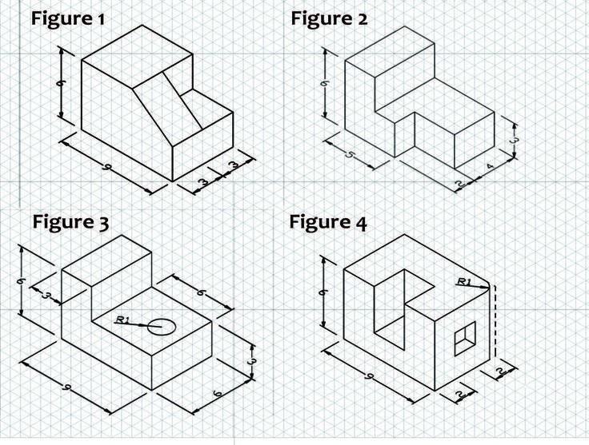

Display drawings for appraisal.
PHASE 3:  REFLECTION | Use peer discussion and effective questioning to find out  from learners what they have learnt during the lesson.  Take feedback from learners and summarize the lesson.  Ask learners how the lesson will benefit them in their daily lives.

Week Ending: 02-06-2023 |  | Day: |  | Subject: Career Technology
Duration: 60MINS |  |  |  | Strand: Technology
Class: B8 |  | Class Size: |  | Sub Strand: Pictorial Drawing
Content Standard:  B8.5.1.1 Demonstrate understanding of drawing plane figures and solid objects using drawing instruments. |  |  | Indicator:  B8.5.1.1.2: Draw objects in pictorial using instruments |  |  |  | Lesson:  2 of 2
Performance Indicator:  Learners can draw plane figures using instruments |  |  |  |  | Core Competencies:  CP 6.5: CI 5.4: CI 5.2: CI 6.10:
Reference: Career Technology Curriculum Pg. 64
Phase/Duration | Learners Activities |  |  |  |  | Resources
PHASE 1:  STARTER | Revise with learners to review their understanding in the  previous lesson.  Share performance indicators with learners.
PHASE 2: NEW  LEARNING | Illustrate the techniques of drawing objects in oblique and  perspective.  Oblique Drawing:  - Receding Lines: In oblique drawing, receding lines are used to represent the depth of an object. These lines are drawn at an angle from the front of the object to the back, giving the appearance of distance and depth. Typically, they converge towards a vanishing point.  - Foreshortening: Foreshortening is a technique used in oblique drawing to depict objects that are closer to the viewer. It involves shortening or compressing the dimensions of the object along the depth axis to create a realistic representation.  - Scale: Oblique drawings often employ a scale to ensure accurate proportions and dimensions. The scale helps maintain consistency and enables viewers to understand the relative sizes of different elements in the drawing.  - Parallel Projection: Unlike perspective drawing, oblique drawing uses parallel projection, meaning that all lines remain parallel in the drawing. This technique simplifies the process and allows for easier construction of the drawing.  Perspective Drawing:  1. Horizon Line and Vanishing Points: Perspective drawing involves the use of a horizon line, which represents the eye level of the viewer. Vanishing points are points on the horizon line where parallel lines appear to converge. These points determine the direction and convergence of lines in the drawing. |  |  |  |  | Pictures and  charts of food

- One-Point Perspective: In one-point perspective, all receding
lines in the drawing converge towards a single vanishing point on the horizon line. This technique is often used for drawing objects or scenes where the viewer is facing directly towards a single point.
- Two-Point Perspective: Two-point perspective uses two vanishing points on the horizon line. This technique is suitable for drawing objects or scenes where the viewer is looking at an angle.

- Three-Point Perspective: Three-point perspective incorporates three vanishing points, with one vanishing point located above or below the horizon line. This technique is often used for drawing objects or scenes where the viewer has an extreme perspective angle.
- Foreshortening: Like in oblique drawing, foreshortening is also applied in perspective drawing to accurately represent objects that are closer to the viewer. It involves compressing or shortening the dimensions of the object along the depth axis to create a sense of depth and realism.
Demonstrate to learners by drawing objects in oblique and perspective using instruments.
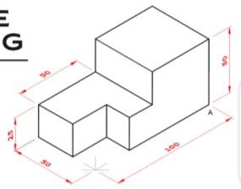

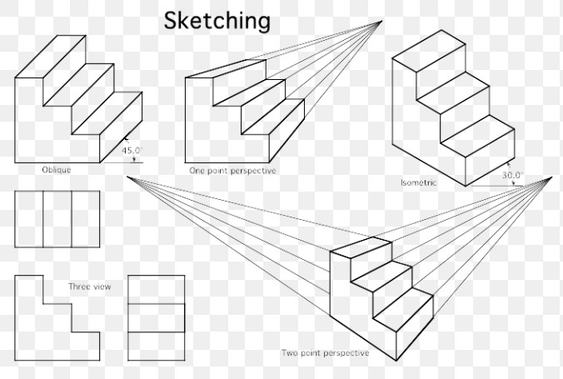

Display drawings for appraisal.
PHASE 3:  REFLECTION | Use peer discussion and effective questioning to find out  from learners what they have learnt during the lesson. Take feedback from learners and summarize the lesson.

Ask learners how the lesson will benefit them in their daily
lives.

