Fayol Inc. 0547824419

SECOND TERM
WEEKLY LESSON NOTES – B8
WEEK 1
Week Ending: 06-04-2023 | DAY: |  | Subject: Computing
Duration: 60mins |  |  | Strand: Productivity Software
Class: B8 | Class Size: |  | Sub Strand: Introduction to Presentation
Content Standard:  B82.2.1 Demonstrate how to use Microsoft PowerPoint (Multimedia) |  | Indicator:  B8.2.2.1.1. Demonstrate how to add pictures, screenshot and edit and format pictures |  |  |  |  | Lesson:  1 of 2
Performance Indicator:  Learners can demonstrate how to add pictures, screenshot and edit and format pictures. |  |  |  | Core Competencies:  CC8.2: CP6.1
Reference: Computing Curriculum P.g. 29
Activities For Learning & Assessment |  |  |  |  | Resources | Progression
Starter (5mins)  Revise with learners to review their understanding in the previous lesson. Share performance indicators and introduce the lesson.  Main (35mins)  Revise with learners on the use of the PowerPoint presentation application.  - PowerPoint is easy to use and has a user-friendly interface that enables users to create engaging presentations quickly.  - PowerPoint is versatile in that it can be used for various purposes, including business presentations, educational lectures, and personal projects.  - PowerPoint presentations can help to enhance communication by presenting information in a clear and concise manner, and by incorporating visual aids that help to convey complex information more easily  Let learners identify and discuss the features of the PowerPoint presentation window.  - Title Bar: The title bar displays the name of the current presentation and allows you to minimize, maximize, or close the PowerPoint window.  - Ribbon: The Ribbon is the main toolbar that contains various tabs, such as Home, Insert, Design, Transitions, Animations, etc., with each tab containing related groups of tools that allow you to perform various tasks in PowerPoint.  - Quick Access Toolbar: The Quick Access Toolbar provides quick access to frequently used commands, such as Save, Undo, and Redo.  - Slides Pane: The Slides pane displays all the slides in the current presentation, and allows you to add, delete, and rearrange slides as needed.  - Notes Pane: The Notes pane allows you to add speaker notes that only you can see during a presentation.  - Slide Area: The Slide Area is the main working area where you can create and edit your slides.  - Status Bar: The Status Bar displays information about the current slide, such as the slide number and the view that you are currently using. |  |  |  |  | Pictures and videos

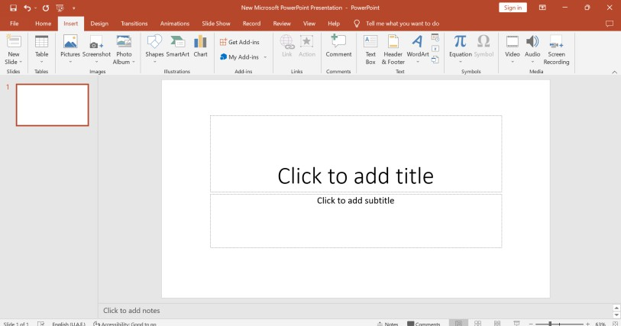

Guide learners to explore the use of the Images Group under the Insert tab.
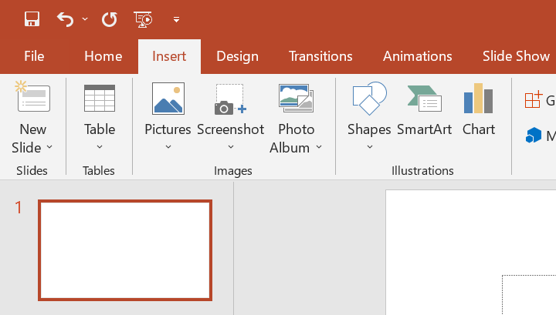
- Pictures: this allows you to add pictures from your computer, stock image library or from online source.
- Screenshot: allows you to add a snapshot of any window that’s open on the desktop to your document.
- Photo Album: It allows you to create a beautiful presentation for your favorite photo collection.

Learners in groups demonstrate the use of ClipArt, Photo Album and Screenshot.
Project examples of the PowerPoint interface to learners with the aid of a projector or pictures.

Reflection (10mins)
Use peer discussion and effective questioning to find out from learners what they have learnt during the lesson.
Take feedback from learners and summarize the lesson.
Homework/Project Work/Community Engagement Suggestions
State and explain the uses of five features of the PowerPoint presentation window
Cross-Curriculum Links/Cross-Cutting Issues
None
Potential Misconceptions/Student Learning Difficulties
None

Week Ending: 06-04-2023 | DAY: |  | Subject: Computing
Duration: 60mins |  |  | Strand: Productivity Software
Class: B8 | Class Size: |  | Sub Strand: Introduction to Presentation
Content Standard:  B82.2.1 Demonstrate how to use Microsoft PowerPoint (Multimedia) |  | Indicator:  B8.2.2.1.2. Demonstrate how to add a drawing  canvas, shapes, and also edit, format and add text to shapes |  |  |  |  | Lesson:  1 of 2
Performance Indicator:  Learners can demonstrate how to add a drawing canvas, shapes, and also edit, format and add text to shapes |  |  |  | Core Competencies:  CC8.2: CP6.1
Reference: Computing Curriculum Pg. 29
Activities For Learning & Assessment |  |  |  |  | Resources | Progression
Starter (5mins)  Revise with learners to review their understanding in the previous lesson. Share performance indicators and introduce the lesson.  Main (35mins)  Explore the use of the Illustrations group under the Insert tab.  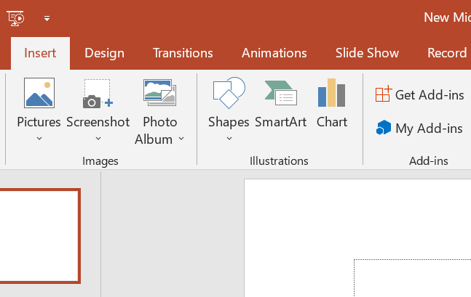  - Shapes: this allows you to insert ready made shapes, such as circles, squares and arrows.  - SmartArt: this allows to insert SmartArt graphics to visually communicate information.  - Chart: this allows you to insert graphs that makes easy to spot patterns and trends in your data. |  |  |  |  | Pictures and videos

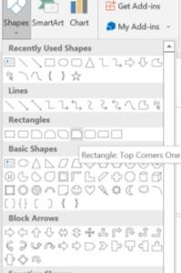
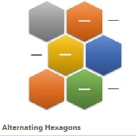
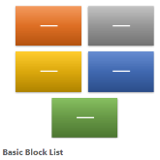
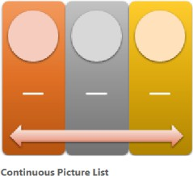
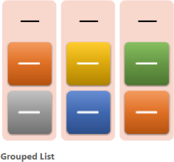
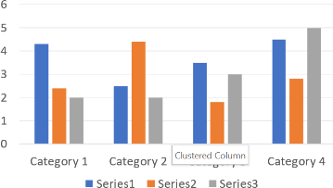
Engage learners to demonstrate the use of Shapes and SmartArt. Explore the use of the drawing canvas to group shapes.
Reflection (10mins)
Use peer discussion and effective questioning to find out from learners what they have learnt during the lesson.
Take feedback from learners and summarize the lesson.
Homework/Project Work/Community Engagement Suggestions
State and explain the uses of five features of the PowerPoint presentation window
Cross-Curriculum Links/Cross-Cutting Issues
None
Potential Misconceptions/Student Learning Difficulties
None

