Fayol Inc. 0547824419

SECOND TERM
WEEKLY LESSON PLAN – B8 WEEK 6

Week Ending: 12-05-2023 |  |  | Day: |  | Subject: Physical and Health Education
Duration: 60mins |  |  |  |  | Strand: Physical Activity Education
Class: B8 |  | Class Size: |  |  | Sub Strand: Physical Fitness
Content Standard:  B8.2.2.3 Demonstrate the ability to increase the level of participation in a variety of flexibility and balance activities |  |  |  | Indicator:  B8.2.2.3.1: Participate in flexibility and balance activities at varying levels of challenge or difficulty |  |  |  | Lesson:  1 of 1
Performance Indicator:  Learners can identify and perform flexibility activities. |  |  |  |  |  | Core Competencies:  CG5.3: CC9.2: CC9.3:
Reference: P H E Curriculum P.g. 25
Keywords: unrestricted, Motion, obstacle, force
Phase/Duration | Learners Activities |  |  |  |  |  | Resources
PHASE 1: STARTER | Welcome learners back from the holidays. Ask them how they spent their  vacation holidays.  Share performance indicators and introduce the lesson.
PHASE 2: NEW  LEARNING | Guide learners to come out the meaning of flexibility and balance.  Flexibility is the ability of joint or series of joints to move through an unrestricted, pain free range of motion.  Flexibility describes the range of motion available at a joint or group of joints.  Balance describes your body`s ability to navigate obstacles and resist force that can cause fall.  Examples of flexibility endurance.  Backward walking, sideways walking, heel walking, toe walking, spoon and egg brisk walk and standing form a sitting position.  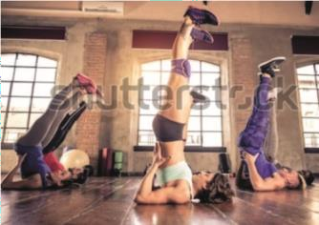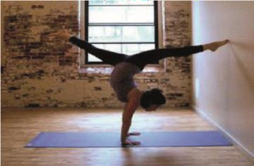  Flexibility Balance |  |  |  |  |  | Picture/video

Guide learners to state some of the benefits of flexibility and balance
- Improve your range of motion
- Reduce aches and pains
- Prevent falls and injury
- Enjoy lifelong benefits

Learners record estimate of duration/measure of performance in your self-journal as your effort to increase involvement in physical activity
PHASE 3:  REFLECTION | Ask learners to do the following by ways of reflecting on the lesson:  - Tell the class what you learnt during the lesson.  - Tell the class how you will use the knowledge they acquire during the lesson.  - Which aspects of the lesson did you not understand?

