Fayol Inc. 0547824419

SECOND TERM
WEEKLY LESSON PLAN – B8 WEEK 7

Week Ending: 19-05-2023 |  |  | Day: | Subject: Physical and Health Education
Duration: 60mins |  |  |  | Strand: Physical Activity Education
Class: B8 |  | Class Size: |  | Sub Strand: Physical Fitness
Content Standard:  B8.2.2.4 Demonstrate the ability to participate in a variety of flexibility and balance activities |  |  | Indicator:  B8.2.2.4.1: Perform a variety of flexibility and balance activities for personal fitness and health development/improvement, decision making and goal setting |  |  |  | Lesson:  1 of 1
Performance Indicator:  Learners can demonstrate a variety of flexibility and balance activities for personal fitness. |  |  |  |  | Core Competencies:  CG5.3: CC9.2: CC9.3:
Reference: P H E Curriculum P.g. 25
Keywords: Sit-and-reach, side bend stretch, butterfly stretch, lunging stretch, triceps stretch
Phase/Duration | Learners Activities |  |  |  |  | Resources
PHASE 1: STARTER | Start the lesson with a recap of the previous lesson.  Allow learners to reflect on what they learnt from the previous lesson relating to muscular strength and endurance
PHASE 2: NEW  LEARNING | Let learners explore in small groups a variety of balance and flexibility  activities.  Help them perform a variety of activities such as sit and reach on the floor (with/without a box), carrying a book on top of the head while going to school, all other carrying activities that keep the body in a good balance, reaching high to pick an object as in house chores, various stretching activities at home and school, etc  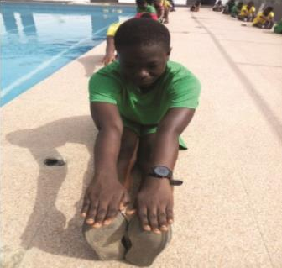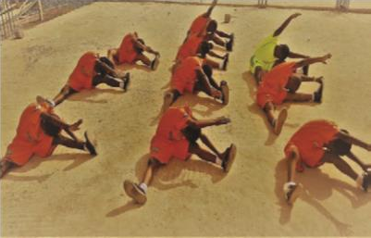  Touch your toes in long sitting position Sit-and-reach alternative leg without a  box |  |  |  |  | Picture/video

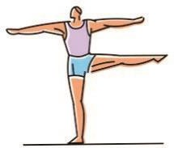
Balance on one leg

Guide learners to ensure free movement of joints, relax muscles as well as good body balance.
PHASE 3:  REFLECTION | Ask learners to do the following by ways of reflecting on the lesson:  - Tell the class what you learnt during the lesson.  - Tell the class how you will use the knowledge they acquire during the lesson.  - Which aspects of the lesson did you not understand?

