Fayol Inc. 0547824419/0549566881

SECOND TERM LESSON PLAN COMPUTING – B7

WEEK 1

Strand : Productivity Software |  | Week Ending: 13th MAY, 2022
Sub Strand: Introduction to Word Processing |  | Duration :50mins
Content Standard: B7.2.1.1 Demonstrate how to use Microsoft Word |  | Class : B7
Indicators: B7.2.1.1.2. Demonstrate how to insert, select, delete and move text |  | Day :
Core competences: DL5.1: Ability to ascertain when information is needed and be able to identify, locate, evaluate and effectively use it to
solve a problem.
Activities For Learning & Assessment | Equipment/Resources |  | Learners Resource  Page Ref. | Progression
Starter (5 mins)  Recap with learners to review their understanding in the previous lesson.  Introduce the lesson by sharing the performance indicators.  Main (35 mins)  Brainstorm learners to come out with the meaning of editing. Editing is the process of correcting mistake changes to the content of a document.  Show projected examples of MS-Word interface with the aid of a computer, projector or pictures. | Set of computer, Video  /pictures |  | Computing  Curriculum Pg. 8-9 | Learning how to  use insert text, move text, delete text, undo, redo and use the spelling & grammar check

Guide learners to discuss the ways of editing a document. Example: inserting text, moving text, deleting text, undo, redo and spelling & grammar check.
Demonstrate to learners, how to insert, move and delete text in a word document.
Example: to insert text
- Move the insertion point to where you want to insert the text.
- Click to place the insertion point
- Start typing the text

Learners practice how to use the undo, redo and spelling & grammar check tools for editing.
Have learners to explore more tools for editing in MS Word.

Explore the use of the overtype or insert option by right-clicking the status bar.

Reflection (10 mins)
We have learnt how to use spelling and grammar check as well as setting language preferences.
Engage learners in a think-pair-share activity to practice how to spell and grammar check text in a passage.
Homework/Project Work/Community Engagement Suggestions
- What is editing?
- State three ways of editing a word document.
- Describe how to insert a text in a word document.
Cross-Curriculum Links/Cross-Cutting Issues
None
Potential Misconceptions/Student Learning Difficulties
The facilitator/teacher can arrange to use a nearby Senior High School (SHS) ICT laboratory.

Strand : Productivity Software |  | Week Ending: 13th MAY, 2022
Sub Strand: Introduction to Word Processing |  | Duration :50mins
Content Standard: B7.2.1.1 Demonstrate how to use Microsoft Word |  | Class : B7
Indicators: B7.2.1.1.3-4. Demonstrate how to find and replace content and undo  edited changes and demonstrate how to spell check, carry out content translation, language setting |  | Day :
Core competences: DL5.1: Ability to ascertain when information is needed and be able to identify, locate, evaluate and effectively use it to
solve a problem.
Activities For Learning & Assessment | Equipment/Resources |  | Learners Resource  Page Ref. | Progression
Starter (5 mins)  Recap with learners to review their understanding in the previous lesson.  Introduce the lesson by sharing the performance indicators.  Main (35 mins)  Guide learners to make use of the Find and Replace tool in MS- Word under the Home tab.  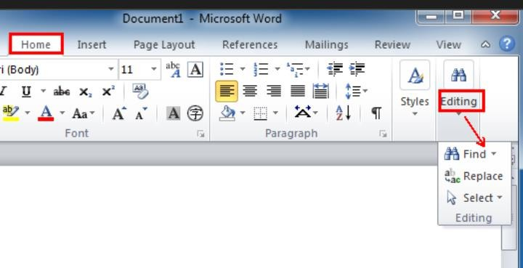 | Set of computer, Video  /pictures |  | Computing  Curriculum Pg. 8-9 | Learning how to  use Find and Replace tool in MS-Word, Proofing and Language group, Spelling & Grammar, Thesaurus

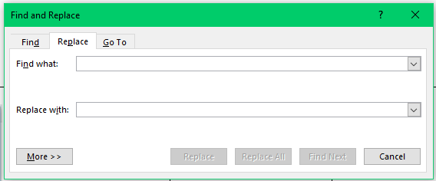
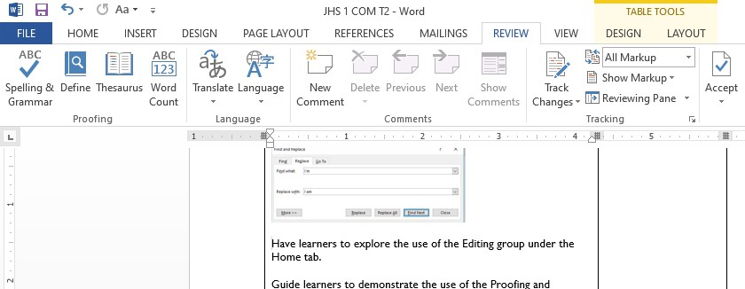
Have learners to explore the use of the Editing group under the Home tab.

Guide learners to demonstrate the use of the Proofing and Language group under the Review tab.

Show how to use the Language, Spelling & Grammar, Thesaurus and other tools in MS-Word under the Home tab.

Reflection (10 mins)
We have learnt how to use replace tool in MS-Word, Proofing and Language group, Spelling & Grammar, Thesaurus.

Engage learners in a think-pair-share activity to practice how to use replace tool in MS-Word and spell and grammar check text in a passage.

Homework/Project Work/Community Engagement Suggestions
- What is editing?
- State three ways of editing a word document.
- Describe how to insert a text in a word document.
Cross-Curriculum Links/Cross-Cutting Issues
None
Potential Misconceptions/Student Learning Difficulties
The facilitator/teacher can arrange to use a nearby Senior High School (SHS) ICT laboratory.

